I found the Hangar 9 Tiger Moth to be a fantastic ARF with very good slow flying characteristics and superb quality.
Why it is no longer available is a real shame.

Over the years of continual flying ( >10 years), I slowly added some scale details to the ARF.
I added basic items like: recovering in cloth, spray painting the lettering, adding the speed indicators and other cosmetic items.

I had modified the firewall from the start to fit the Saito FG36.
This engine gives a very nice sound and being large for the aircraft allowed the aircraft to just gracefully fly around the field in a very scale like way.

This was one of my regular flying aircraft for many years. Transport and assembly can always be a problem with bipes, I used to only remove one wing side so that the aircraft could fit nicely in my trailer and be quick to assemble.

I lost my Tiger moth several months ago due to a transmitter antenna failure in which I lost radio connection.

I loved this aircraft, I was fortunate in being able to purchase another one still in the box from a kind friend.

I am now midway in the process of going full out in stripping this Kit and adding as much detail as I am capable of doing.
I know this aircraft is a delight to fly so all the effort is justerflyable.

If there is interest in the Hangar 9 Tiger Moth I will be happy to post my scale detailing methods.

Kind regards

John. A

Below are images and memories of my Old Tiger.
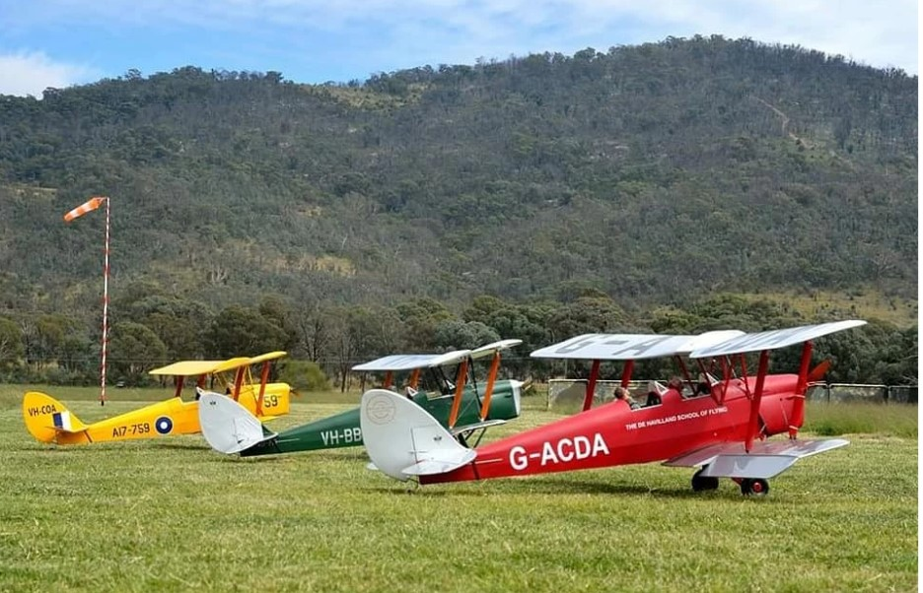

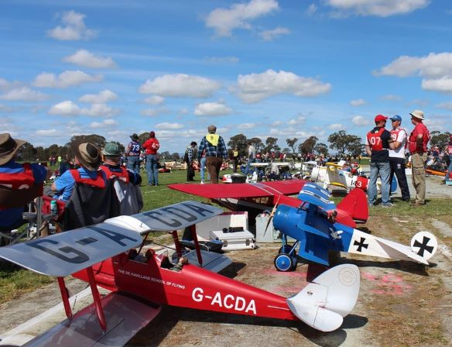
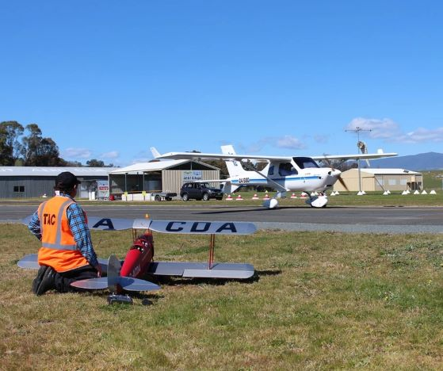

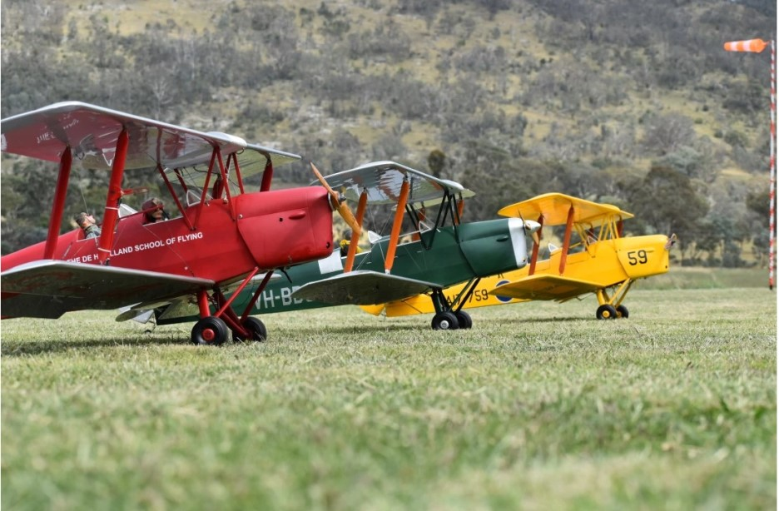

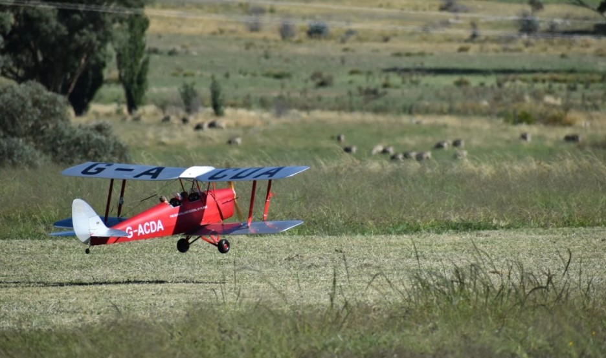
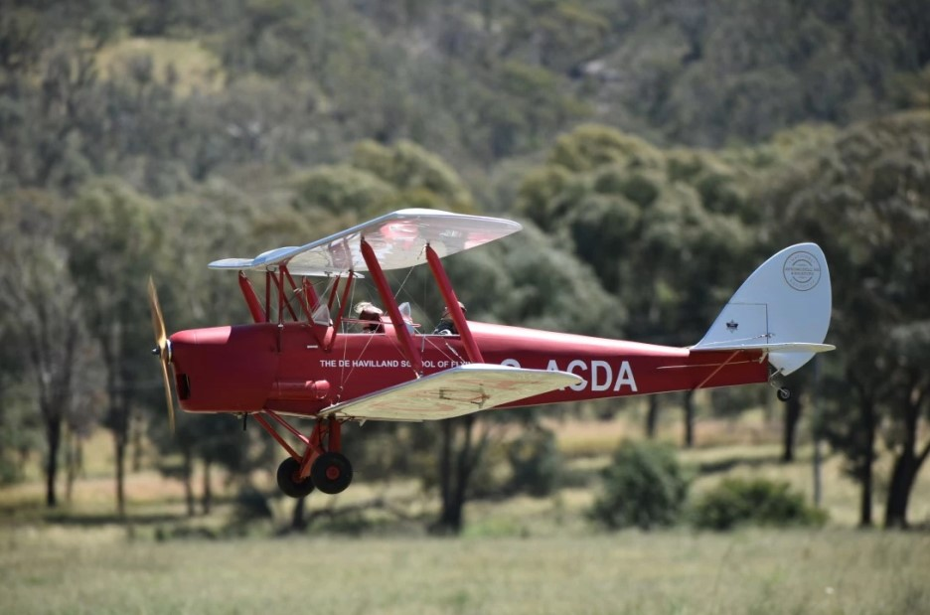
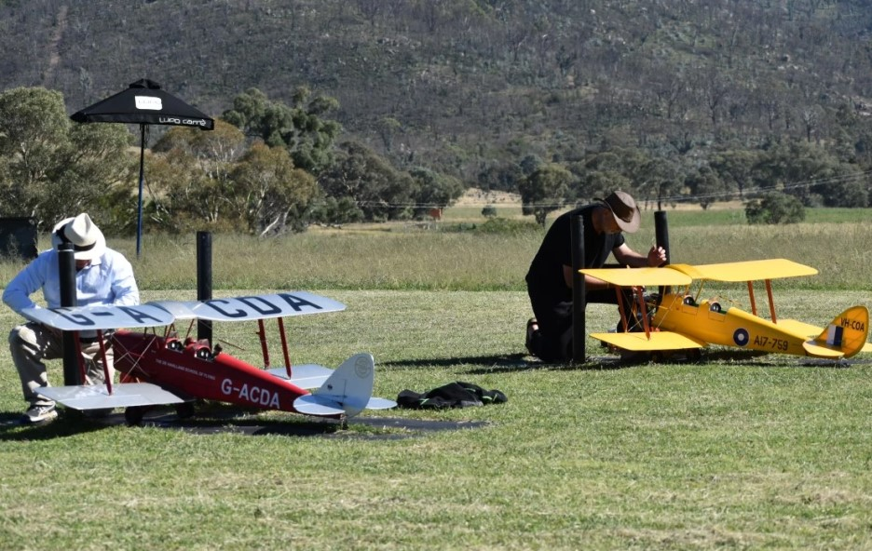

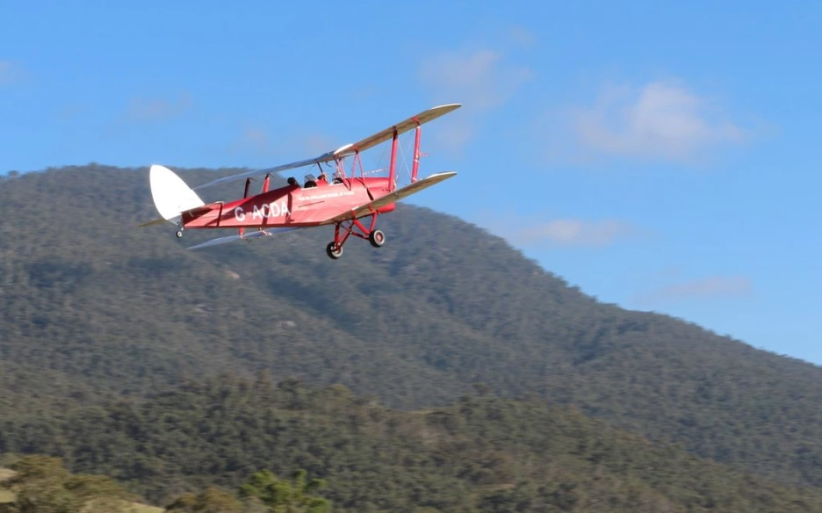
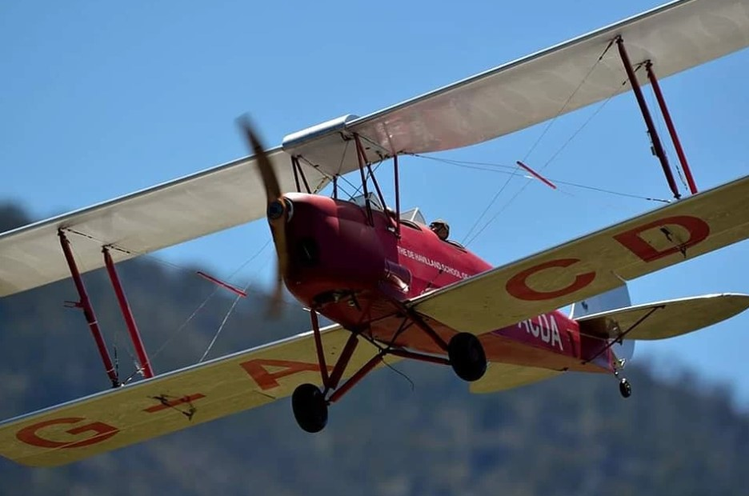
Tiger Moth Recovering.

Just a quick Photo role of recovering the Hanger 9 Tiger moth in cloth.

I use white wood glue, 100% Acetate (Bemsilk or equivalent Lining fabric) and dope.
This technique has worked well for me for years.

The white would glue is laid down around the perimeter and ribs etc, with my finger and then the cloth is laid down over the surface.
The covering can then be gently pulled from the outer edges until all the wrinkles are removed. You can slightly spray the covering with water to keep the glue soft until you are happy.

Once dry 2 -3 coats of dope are applied.
I some times use colored acetate on some application because you then do not need to use as much paint to get full colour.
I have written full article on how to do this over the years.

I have recently been using some of the Dynamic balsa products along with some of my own for getting the surface detail. Dynamic Balsa stuff is really nice to work with.… www.dbalsa.com.

Keep points.

- Covering using Acetate ready for painting.
- Adding scale detail to the surfaces.
- Shortened the engine mount for FG35 cc
Stay safe and well, happy building.

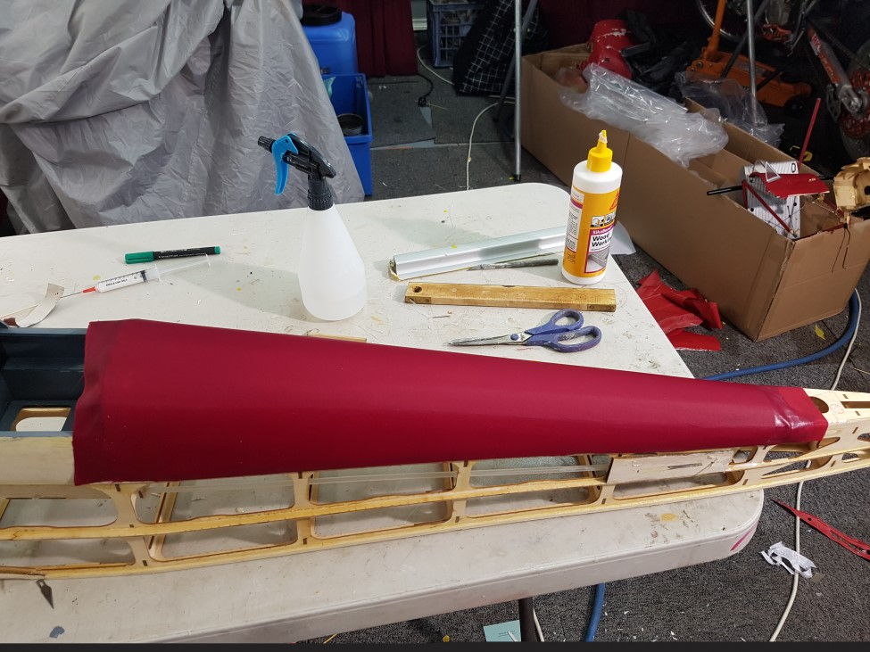

https://www.rcscalebuilder.com/forum/uploads/JohnA/images/2021-09-15_190955_46.jpg

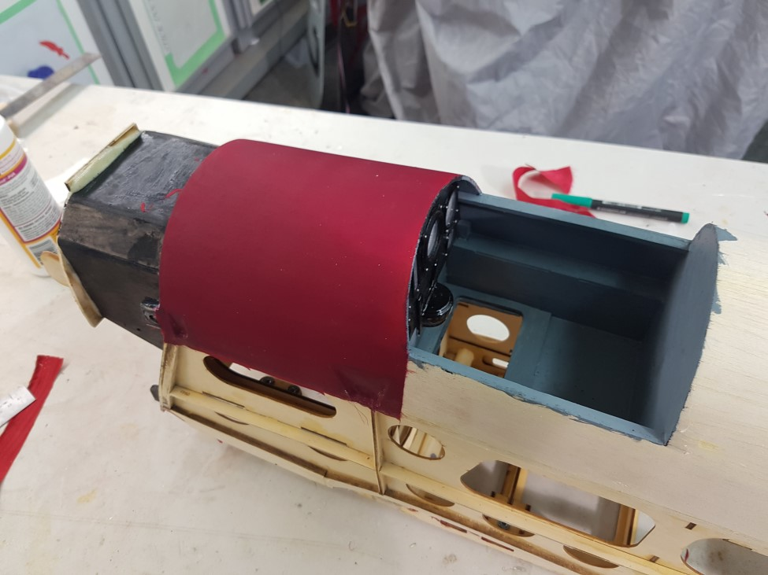

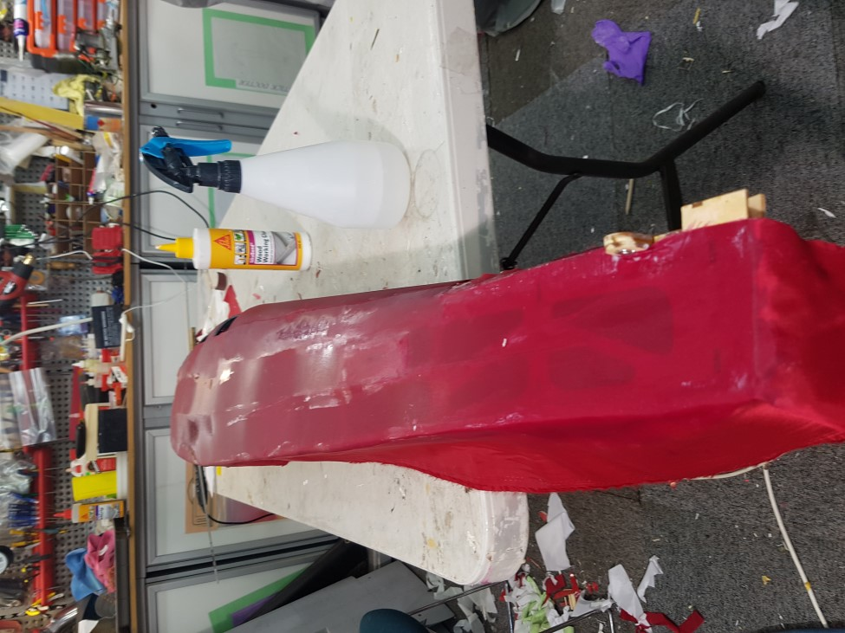

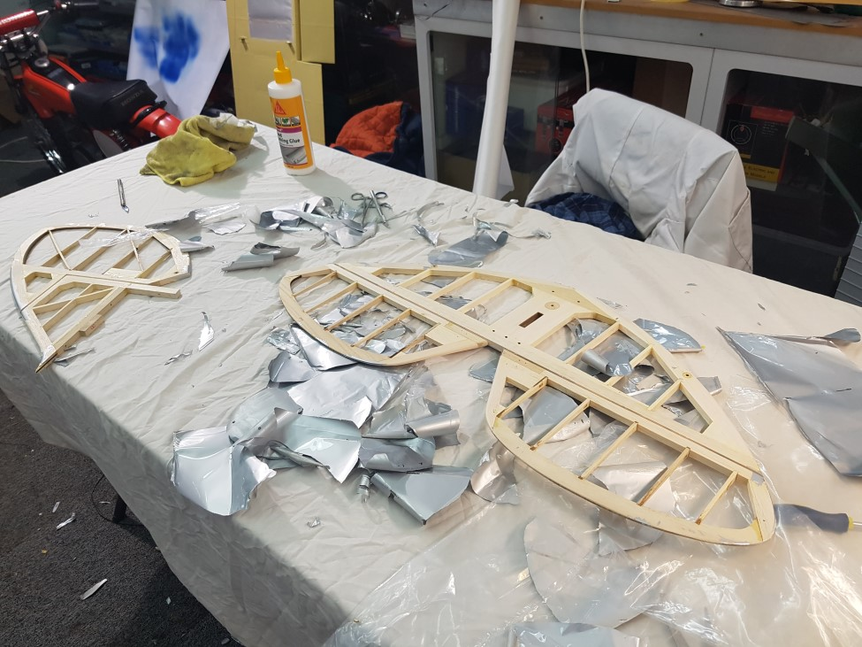

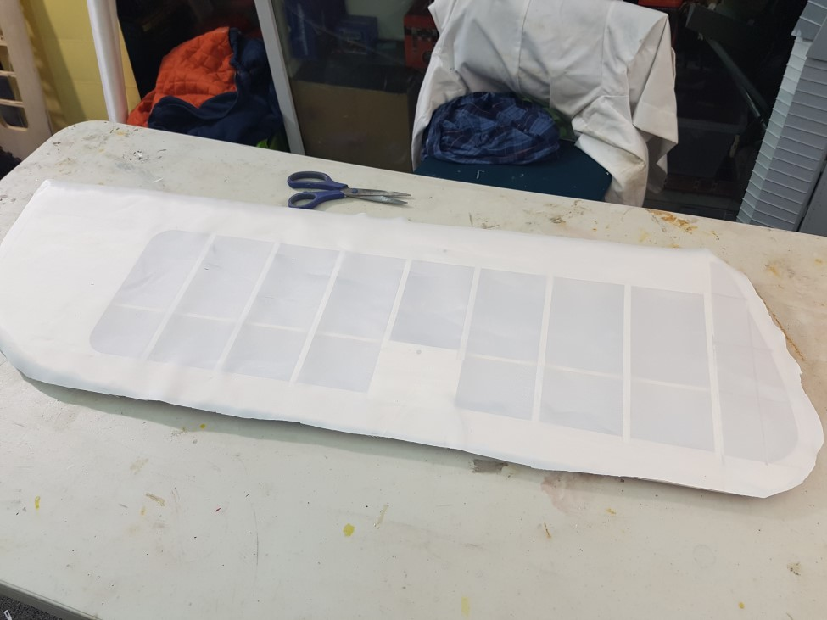

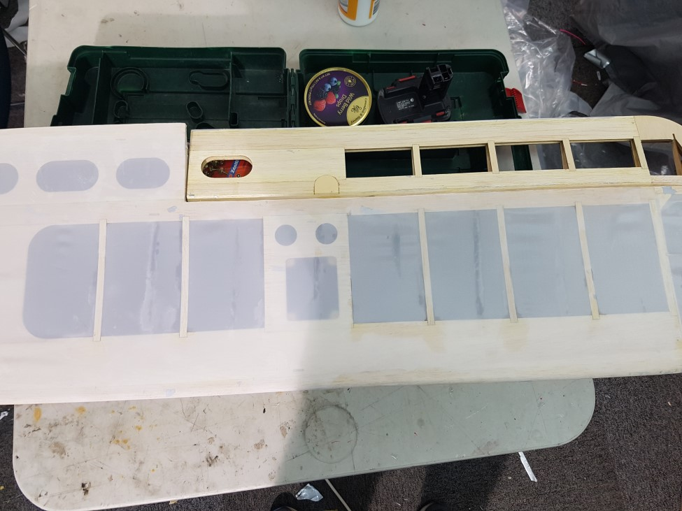

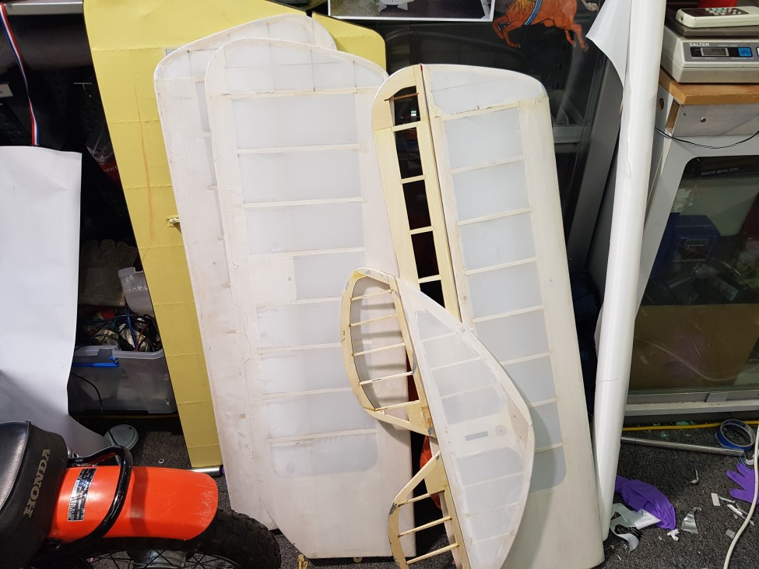

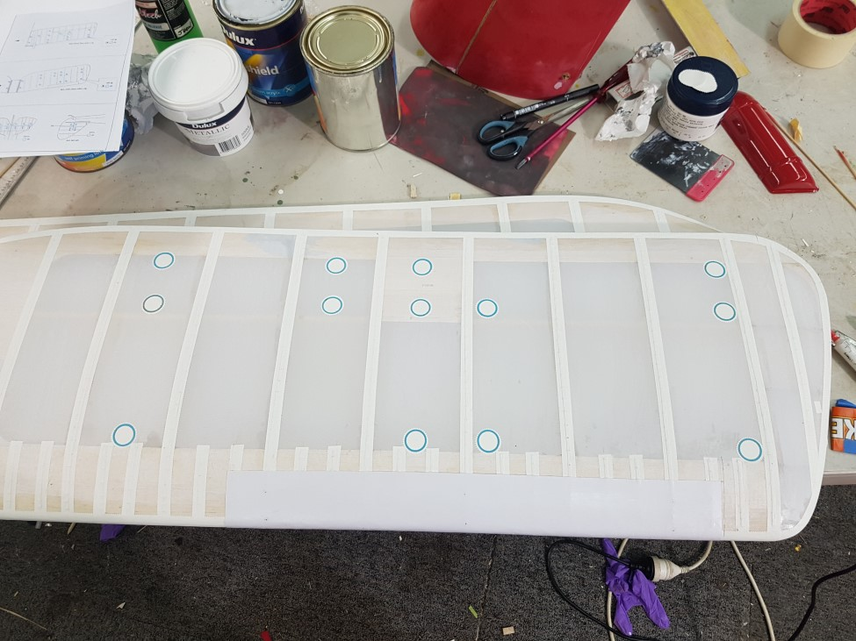

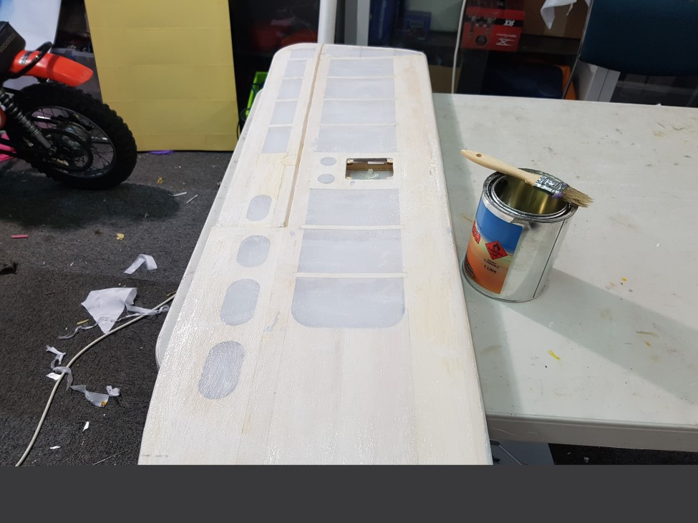
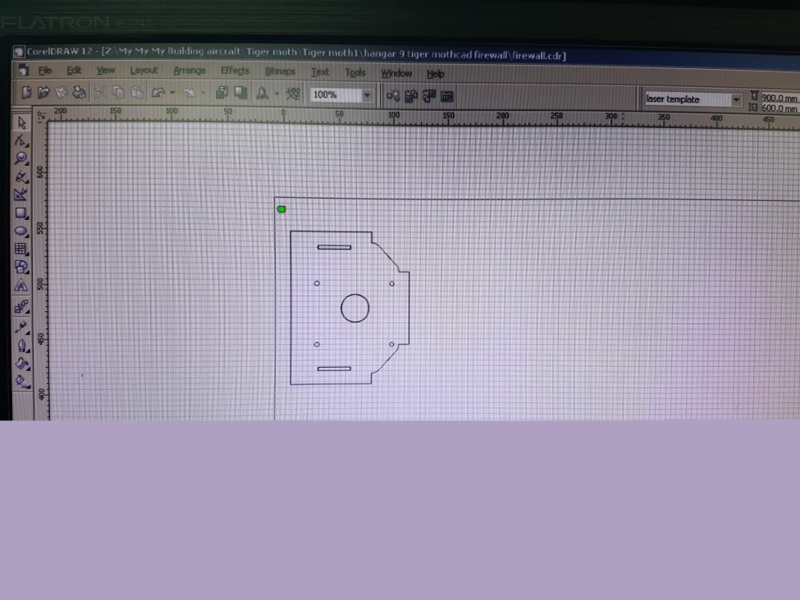

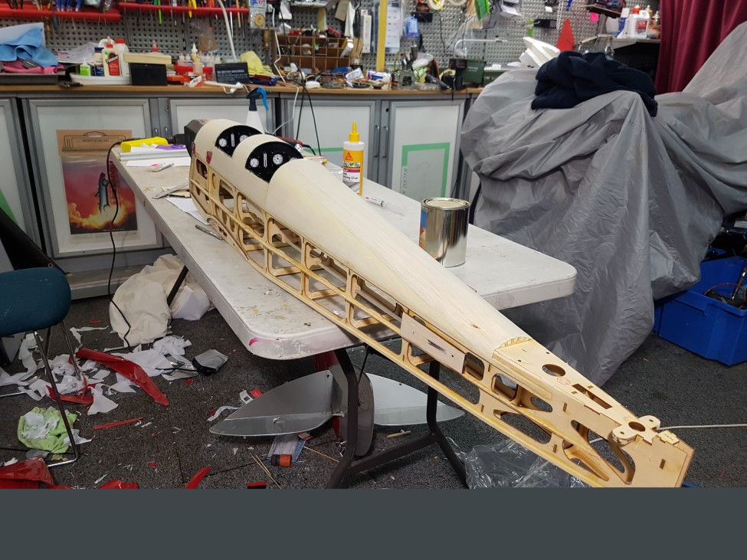

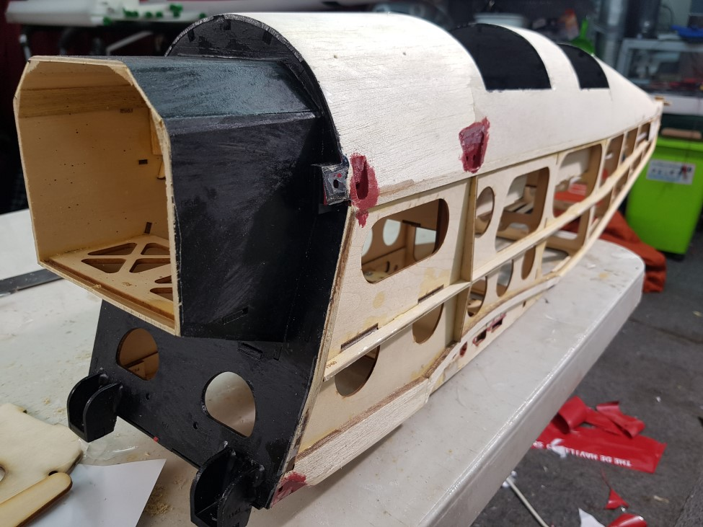

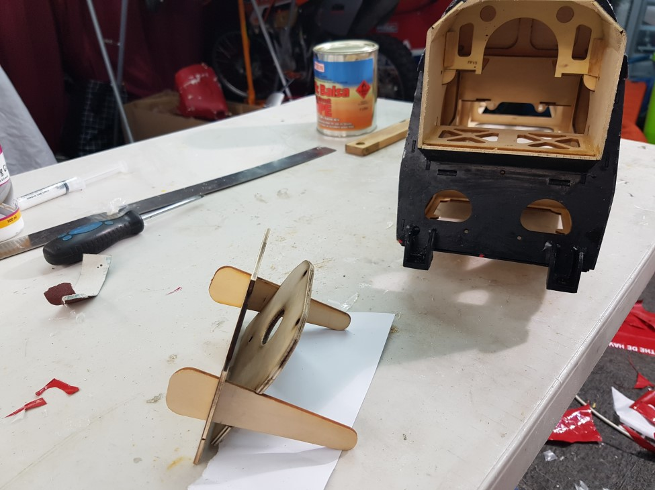

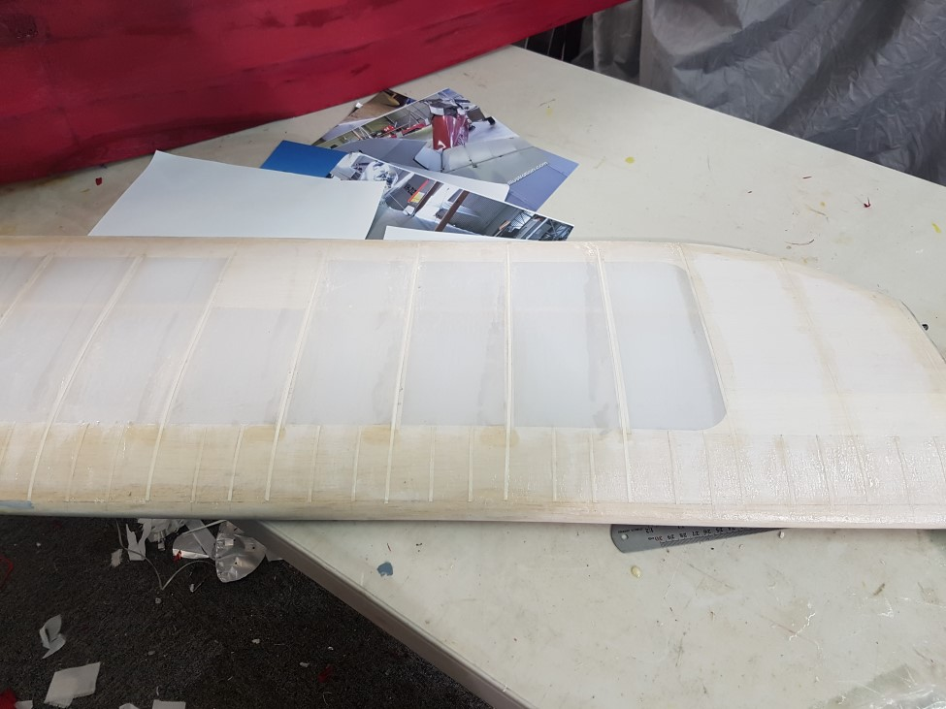

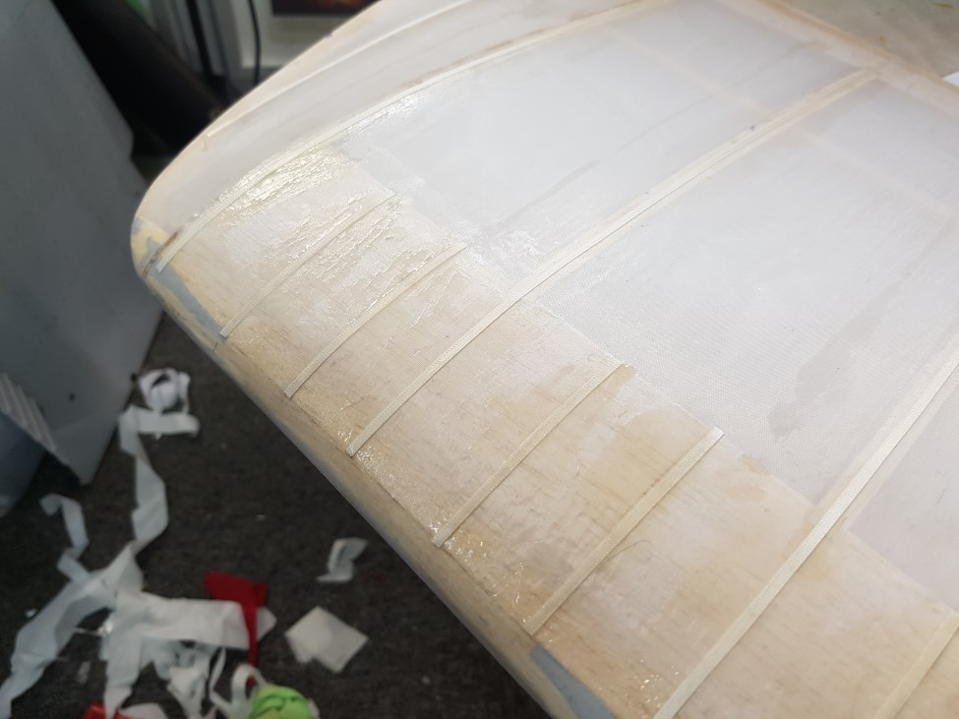

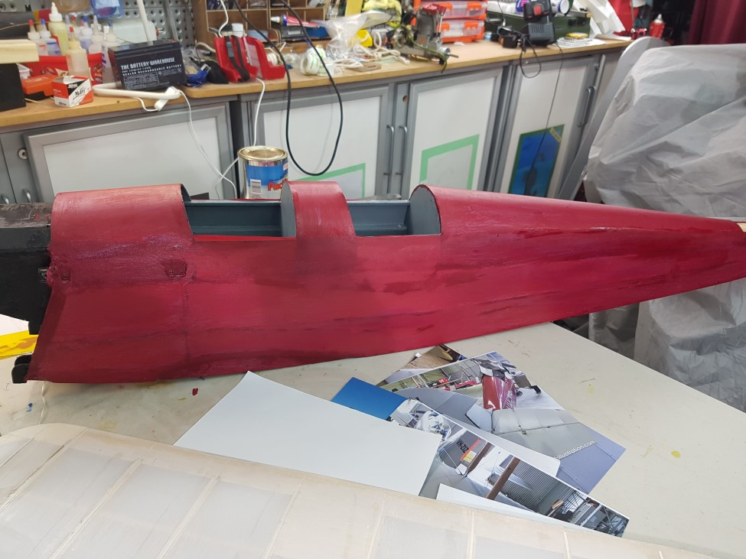

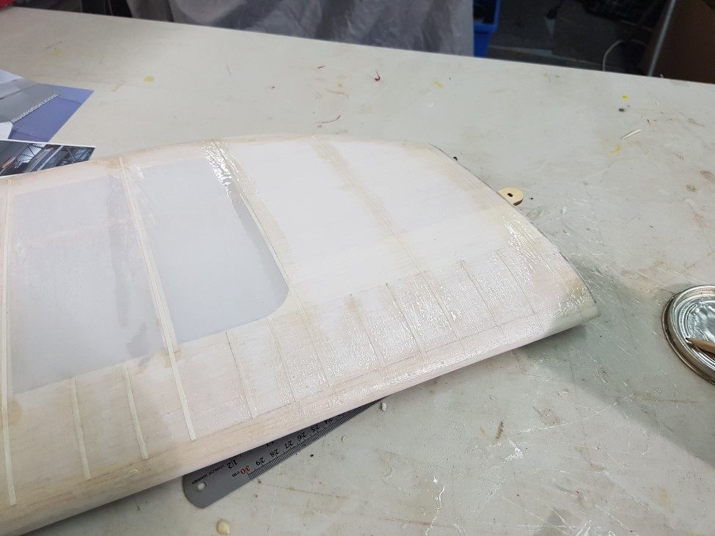

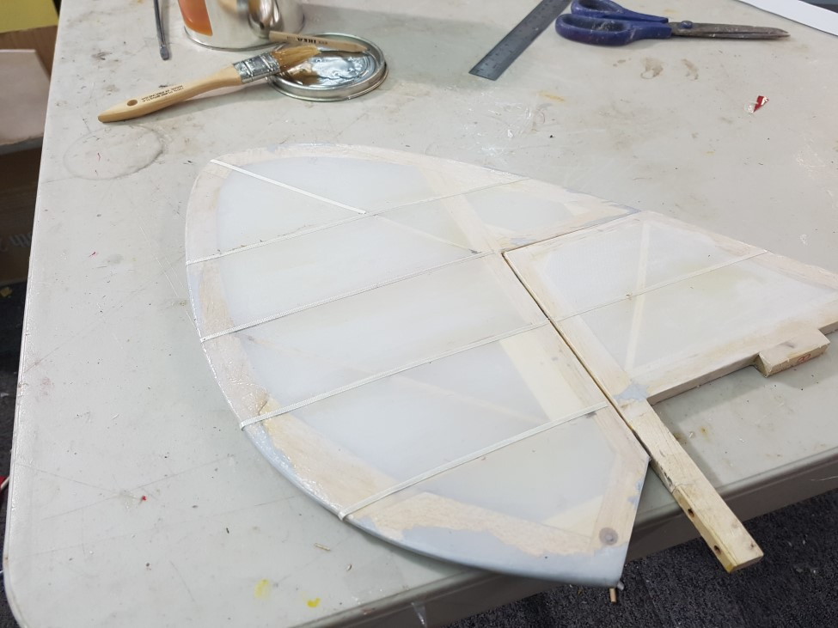

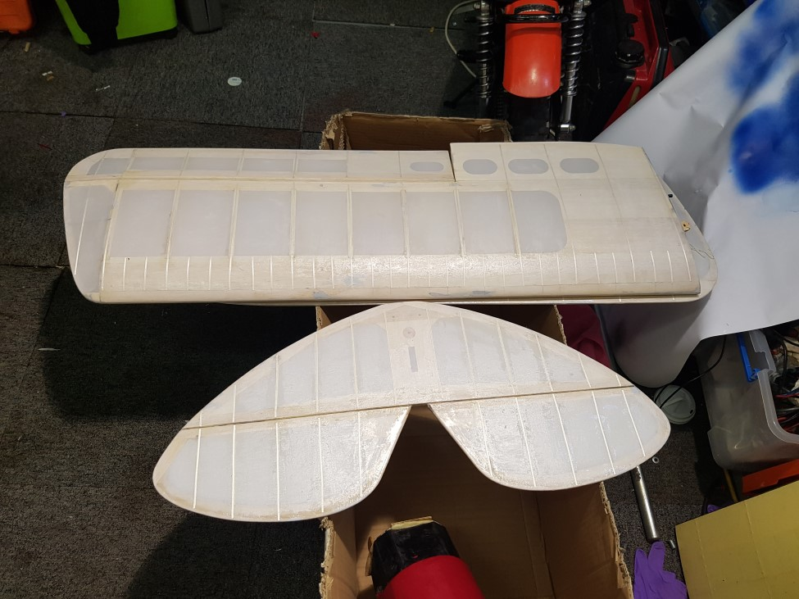

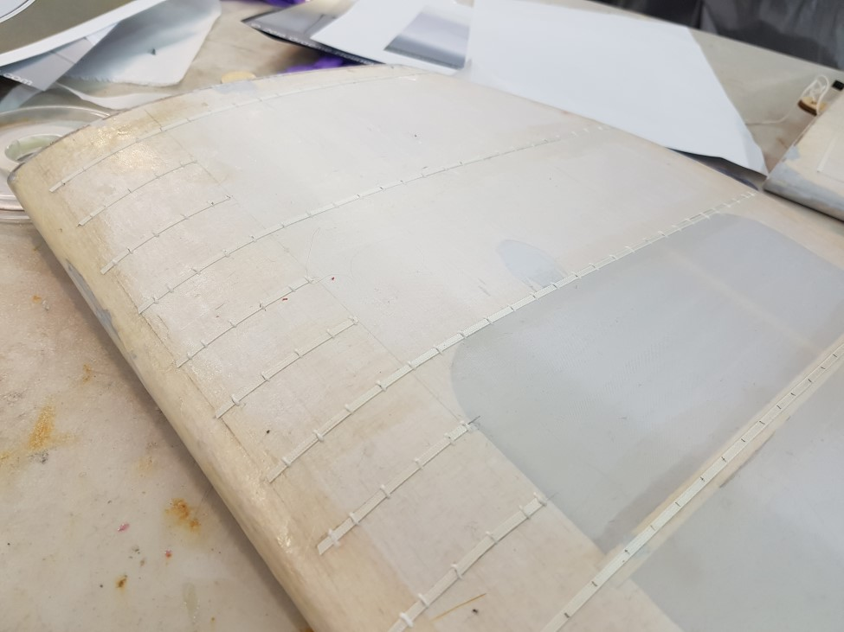

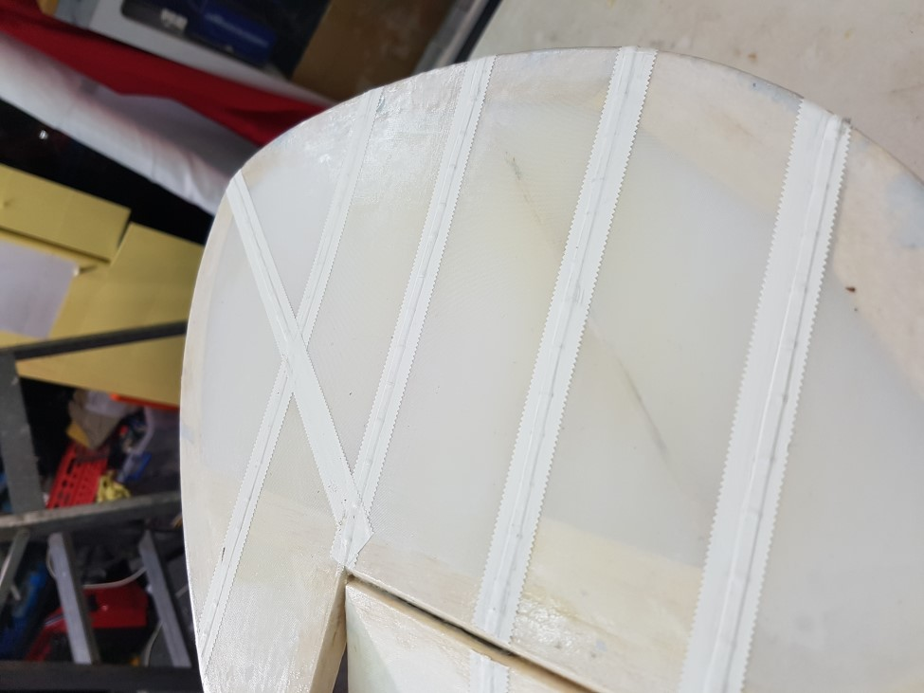

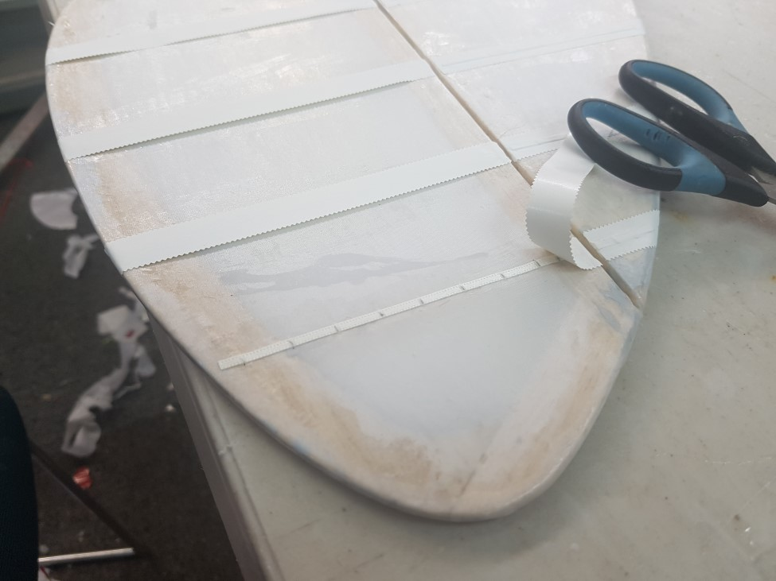

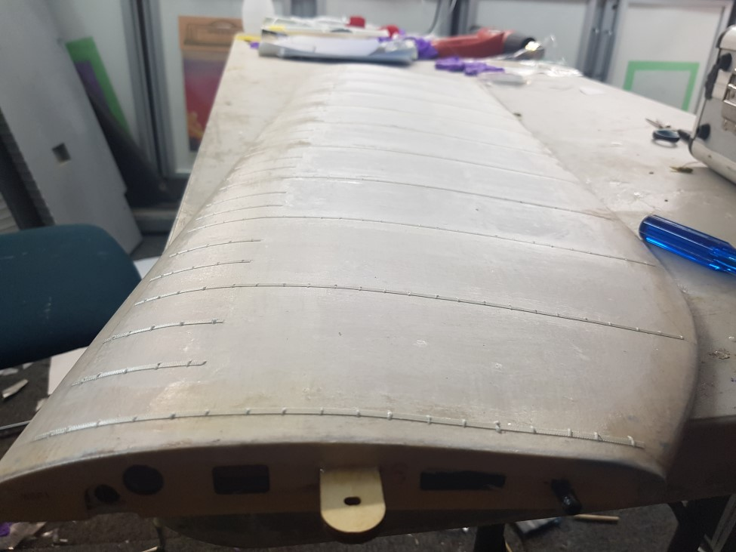

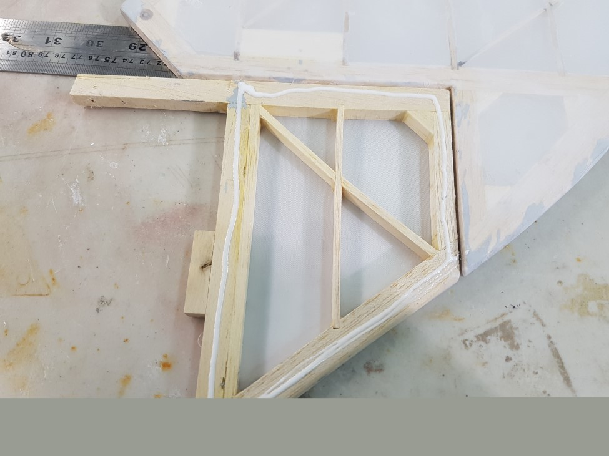

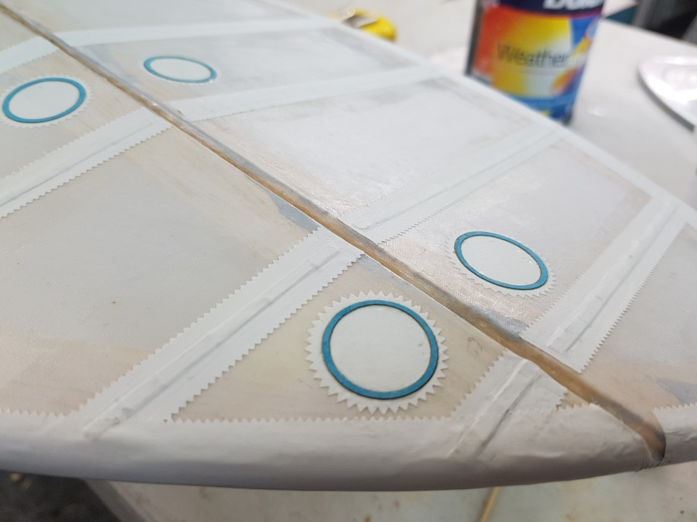

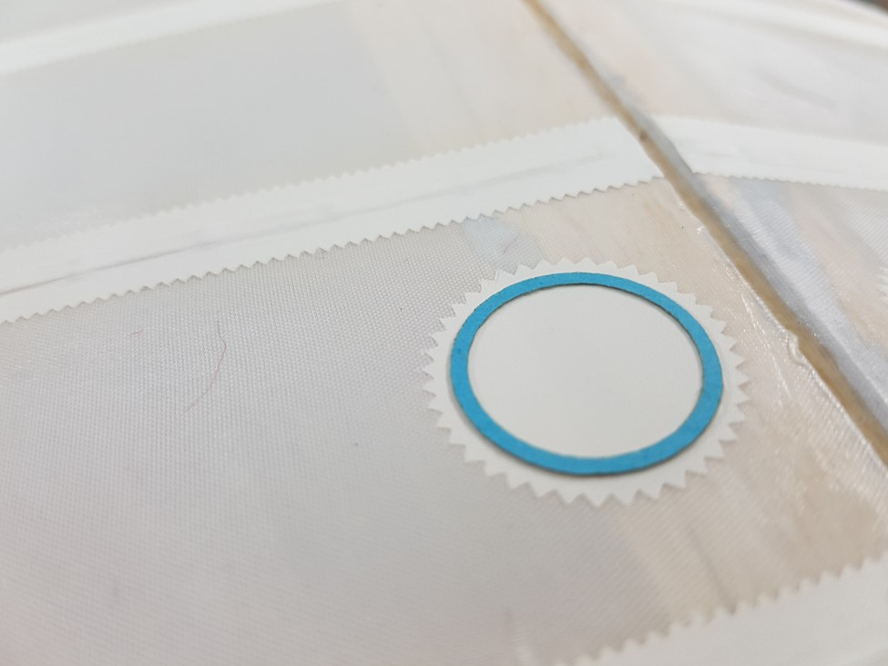

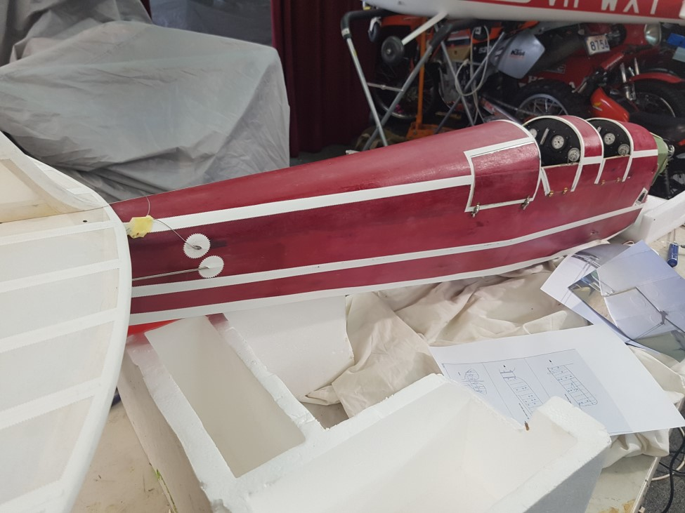

Tiger Moth cowl make over

Just a quick Photo role of modifying the Hangar 9 cowl to provide easy access to the engine and some scale detail.

Keep points.

- I used small dolls house or similar brass hinges for the opening sides.
- I made my own ¼ turn spring loaded latches as I have done previously for my 1/3 scale Sopwith pup as they worked so well
- I cut some litho plate softened it with heat and folder it around to form the front air intake as per the full size aircraft.
- Also re-shaped the right hand air intake duct.

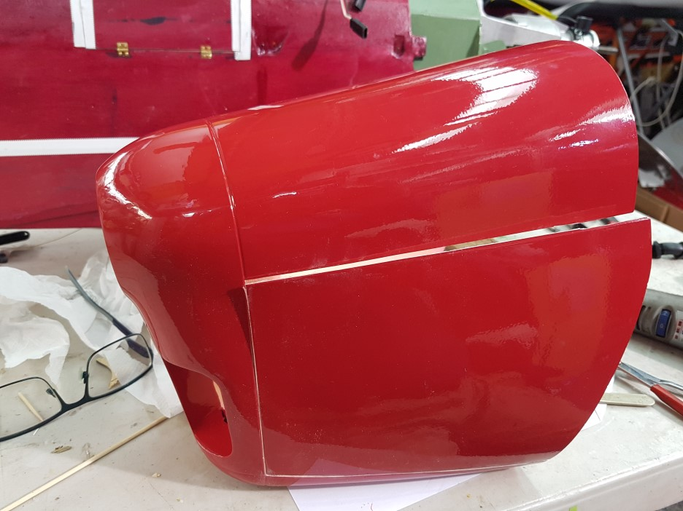

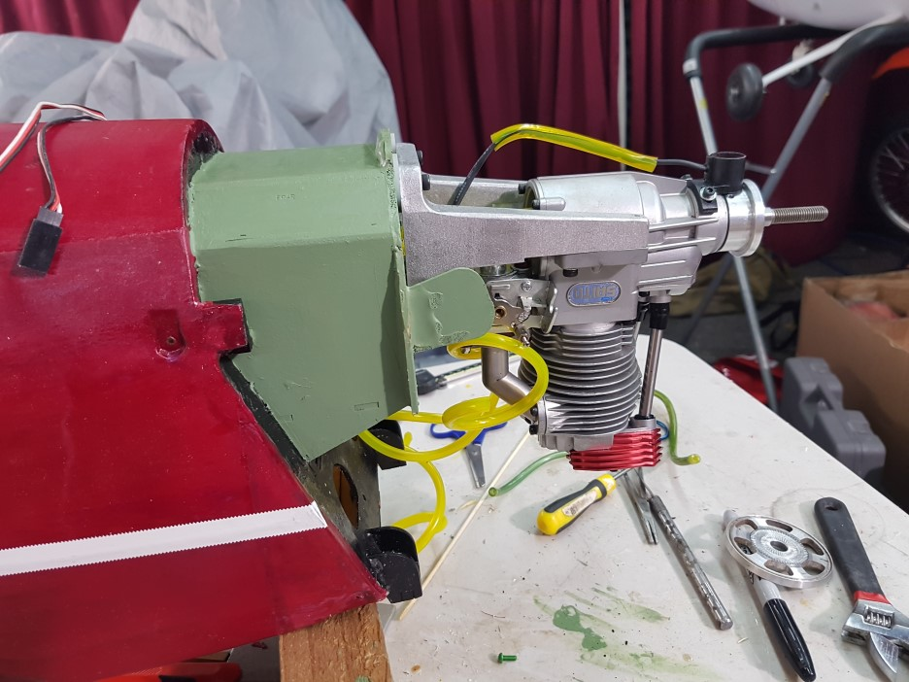

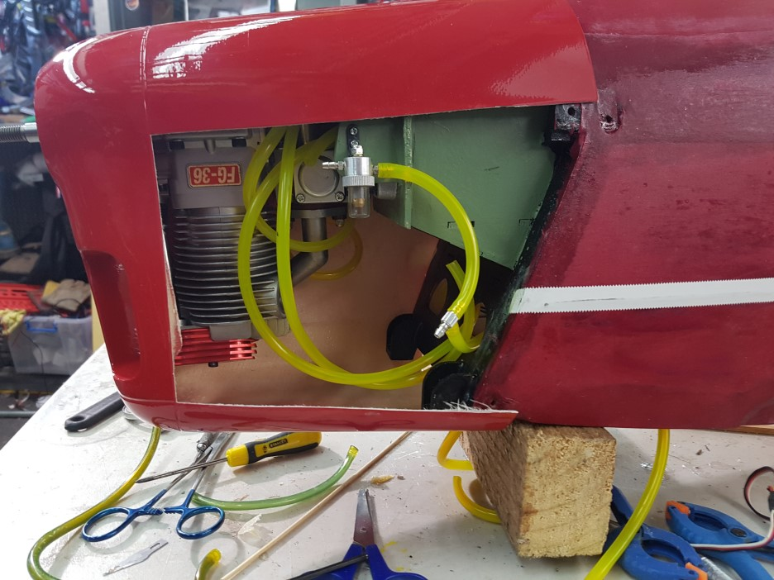

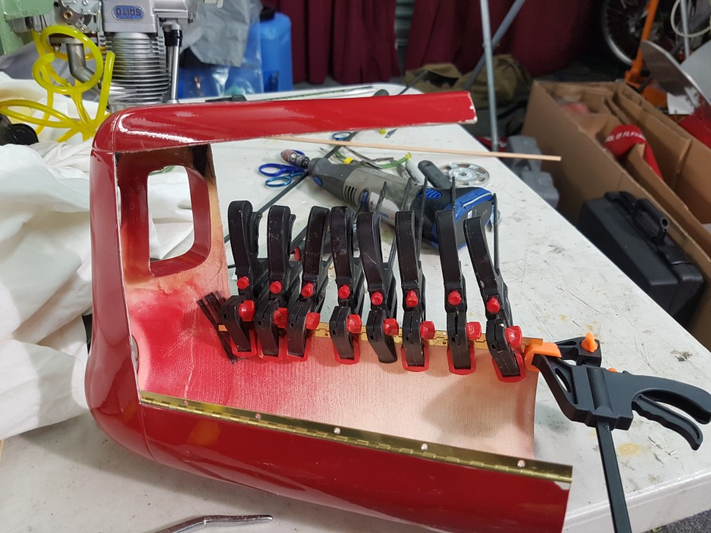
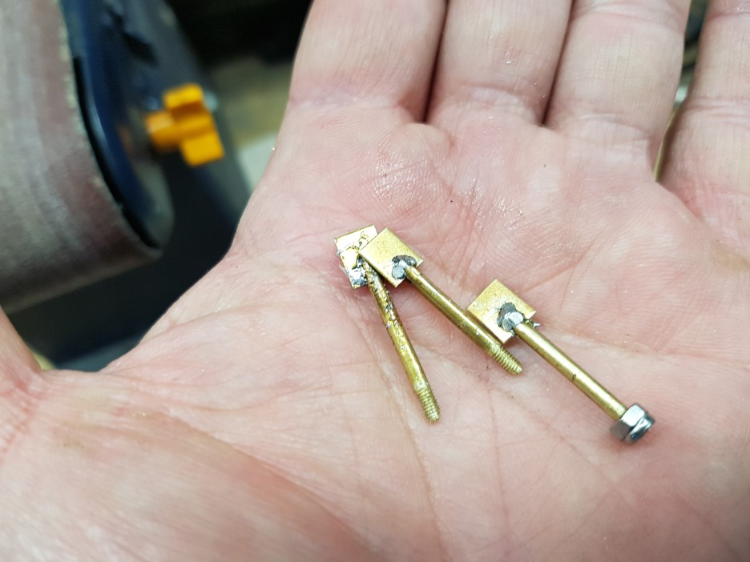

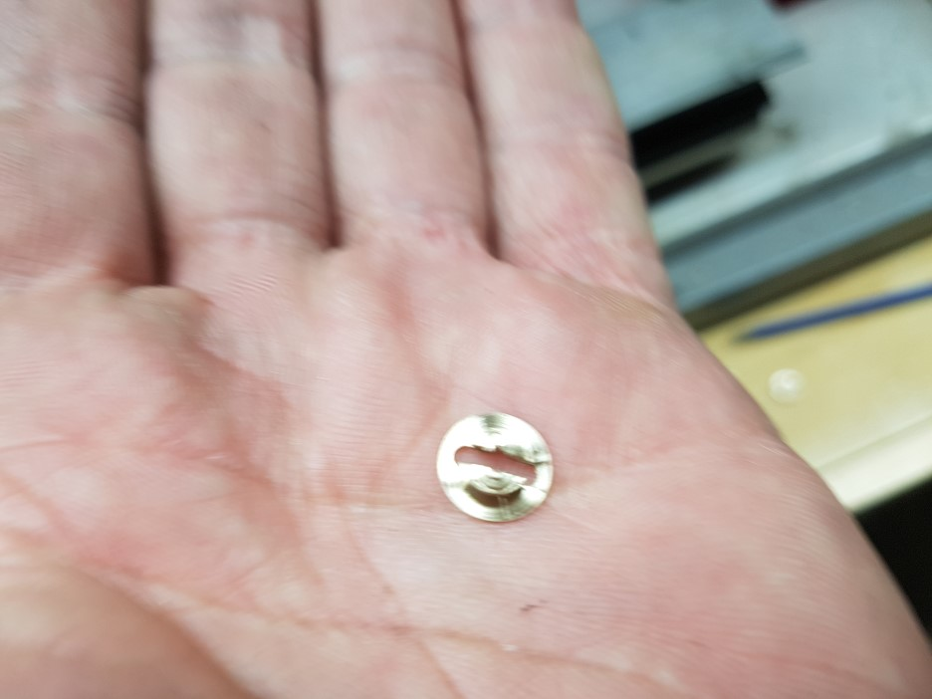

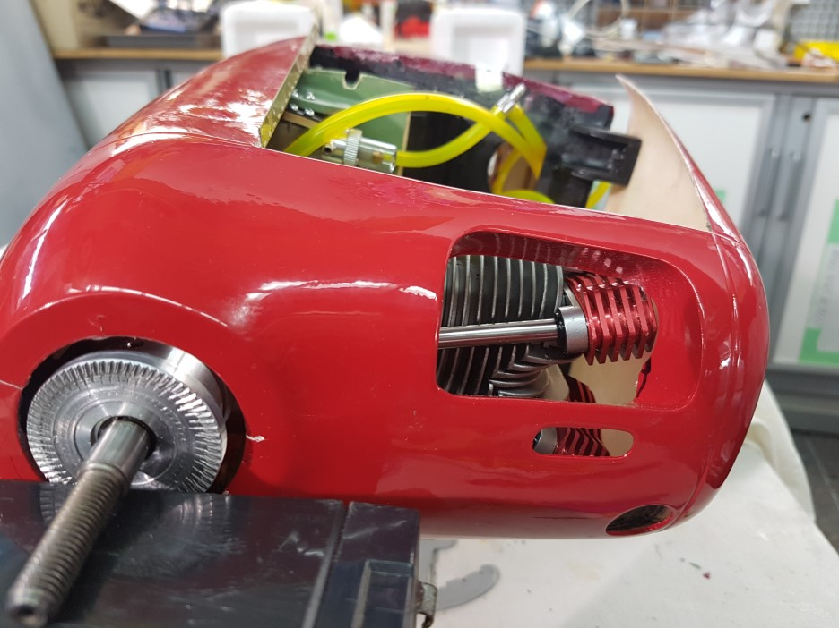
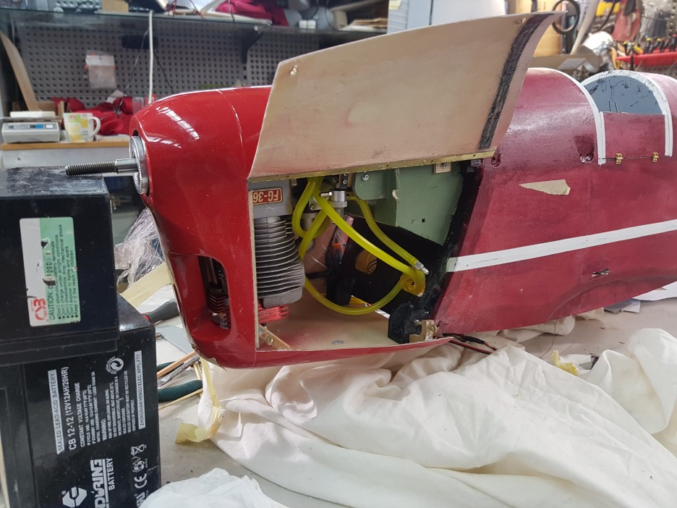
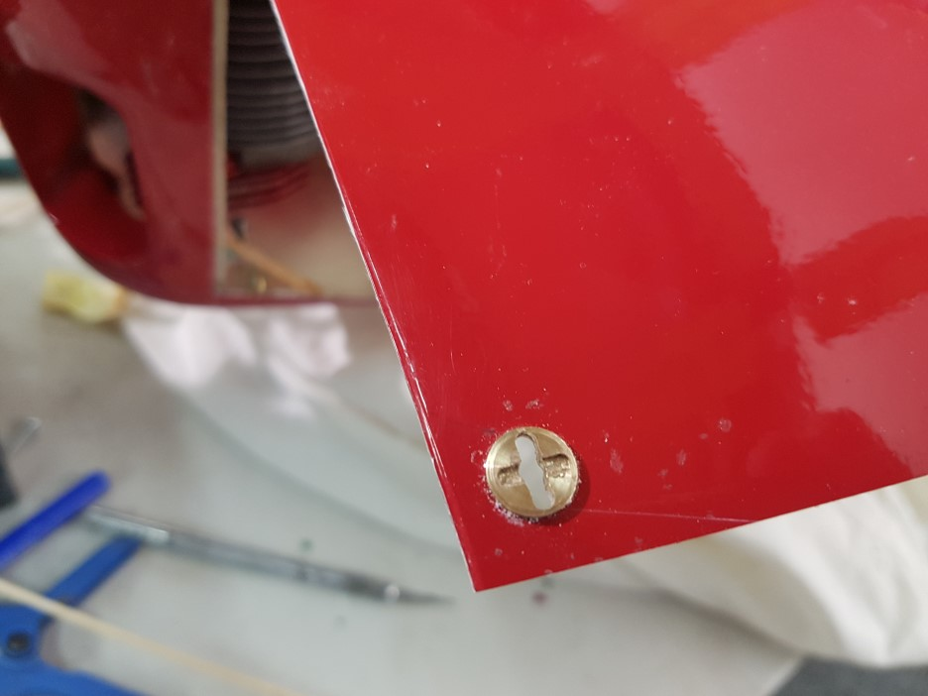

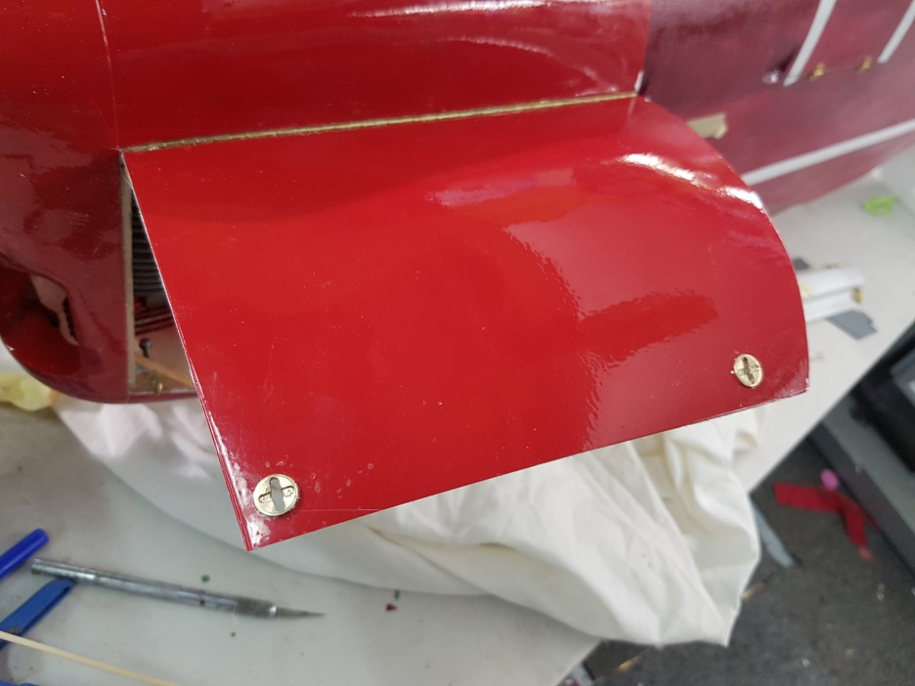

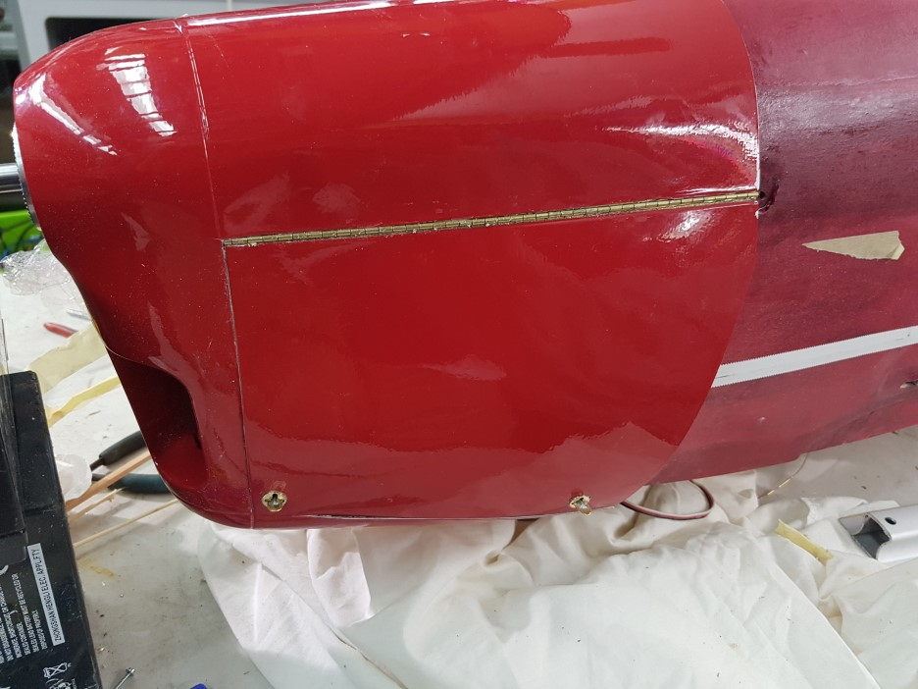

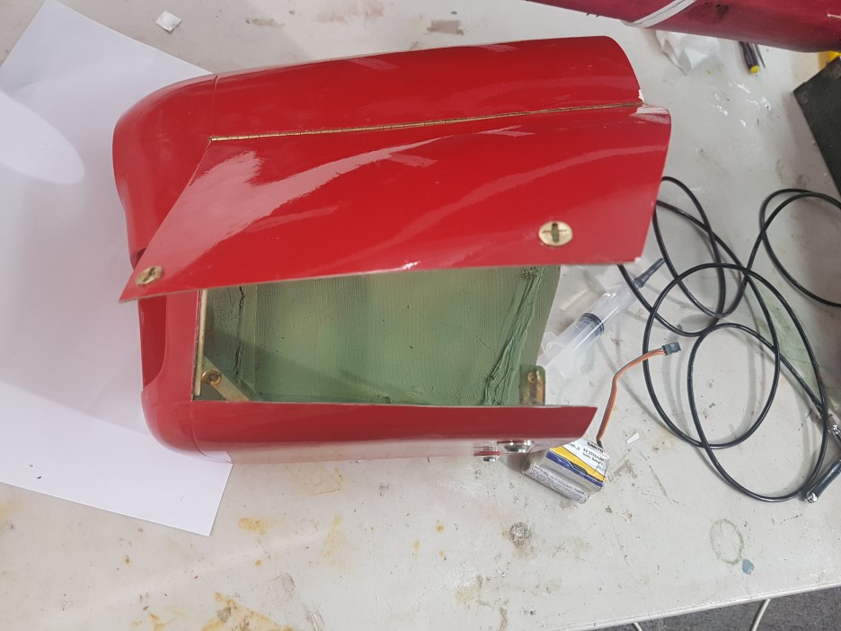
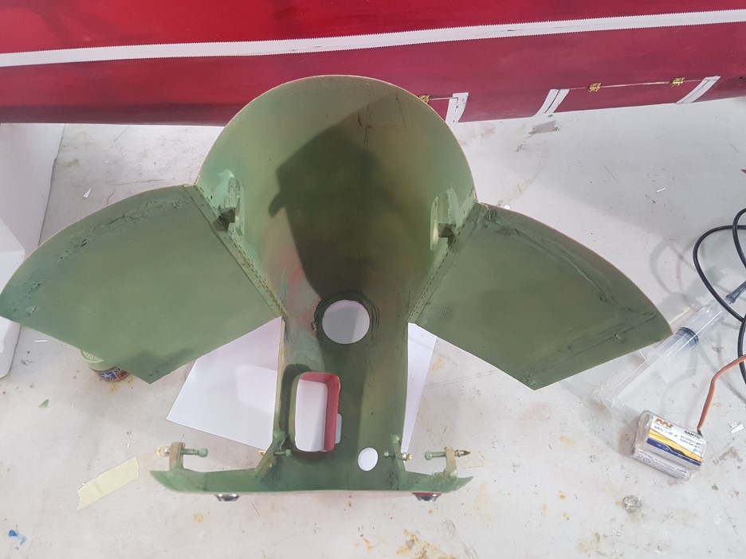

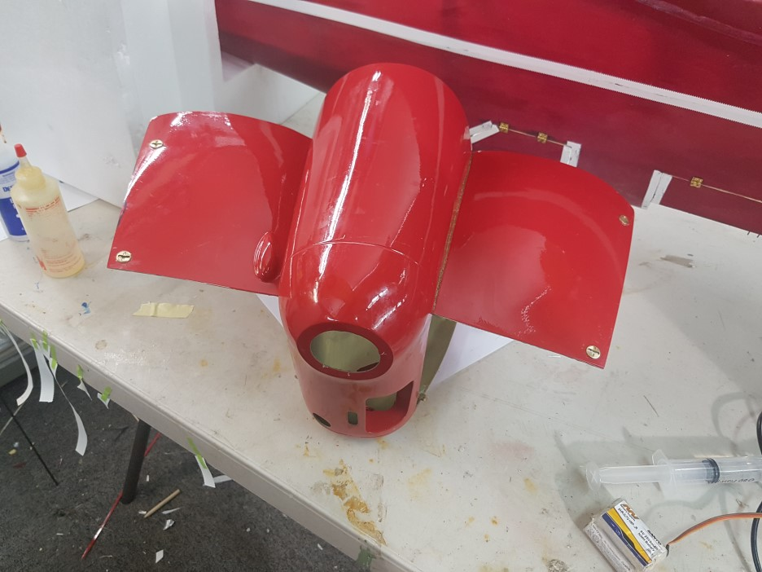

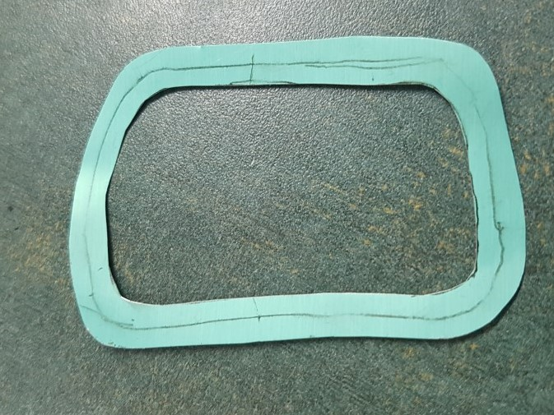

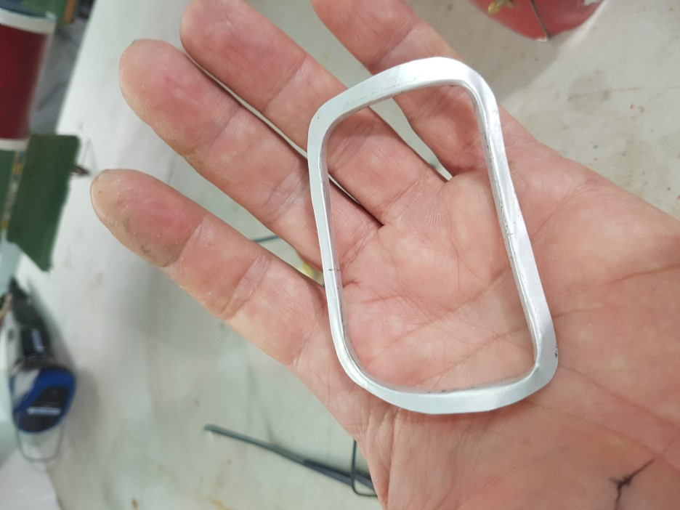

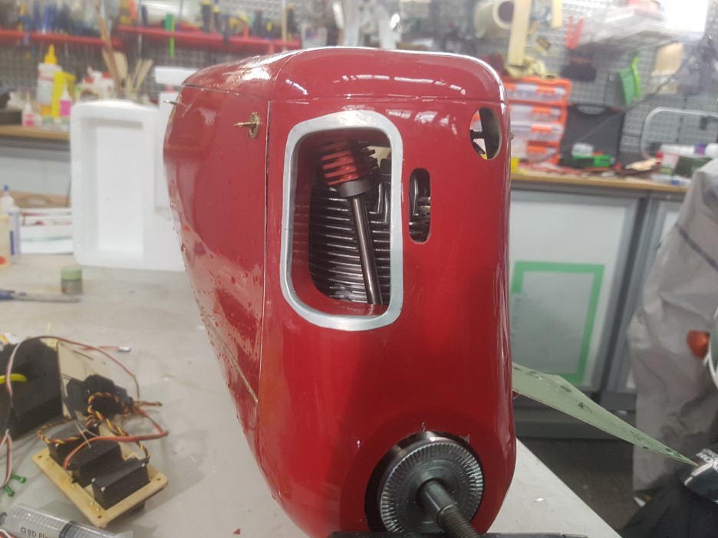
Tiger Moth step and oil tank

Just a quick Photo role some more bits added to Hangar 9 tiger moth, step and oil tank detail

Keep points:

• Just some small bits made from litho plate and the step boot was made from a rubber glove.

Stay safe and well, happy building.

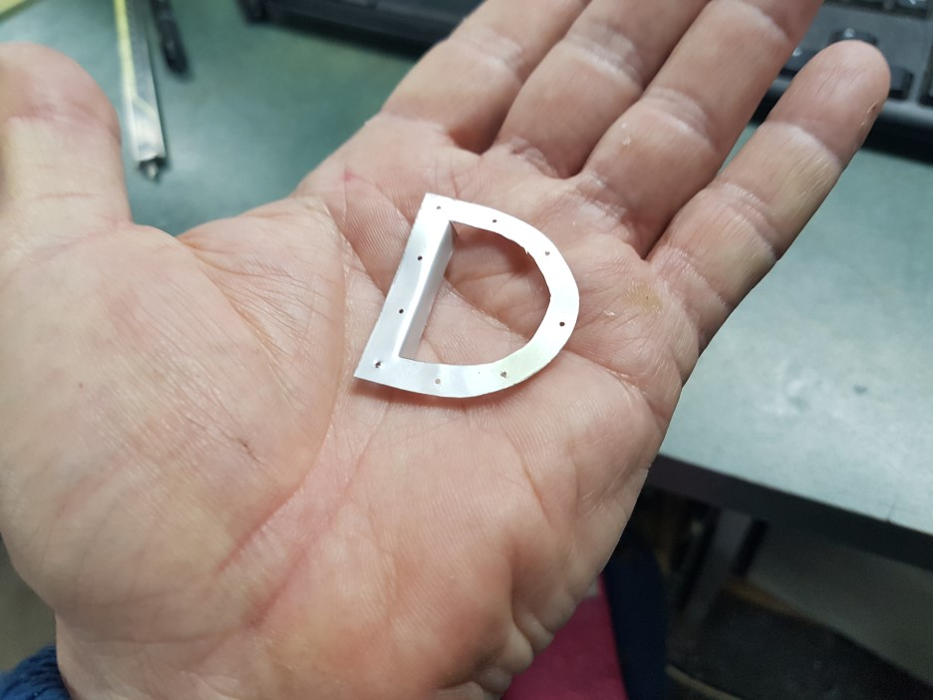

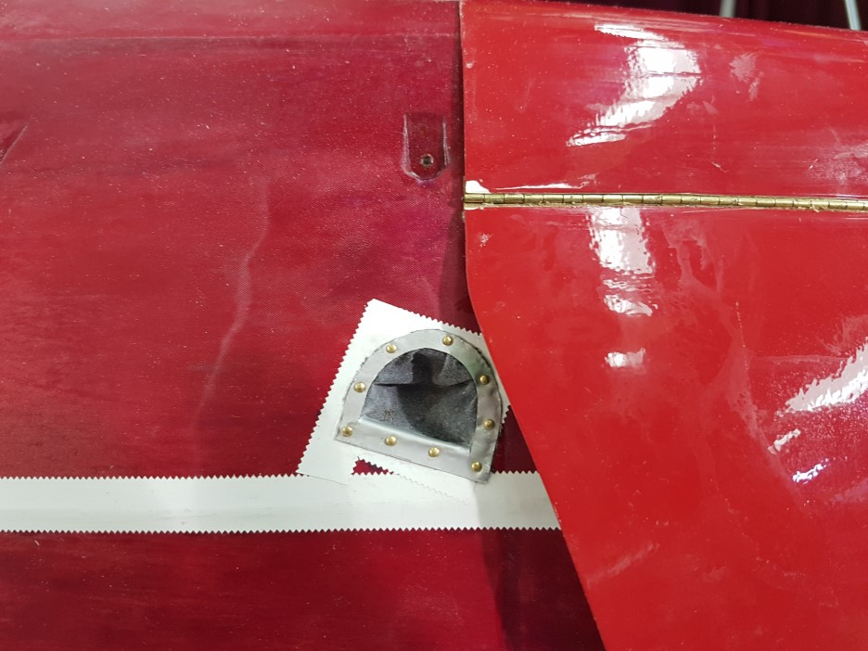

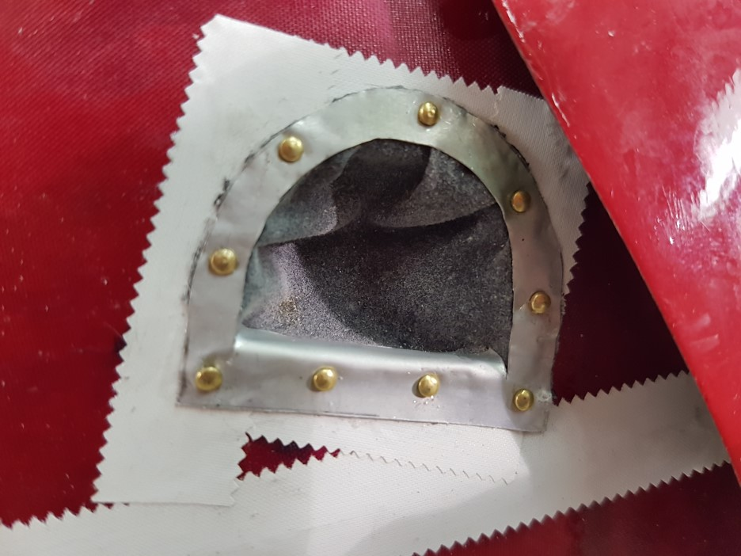

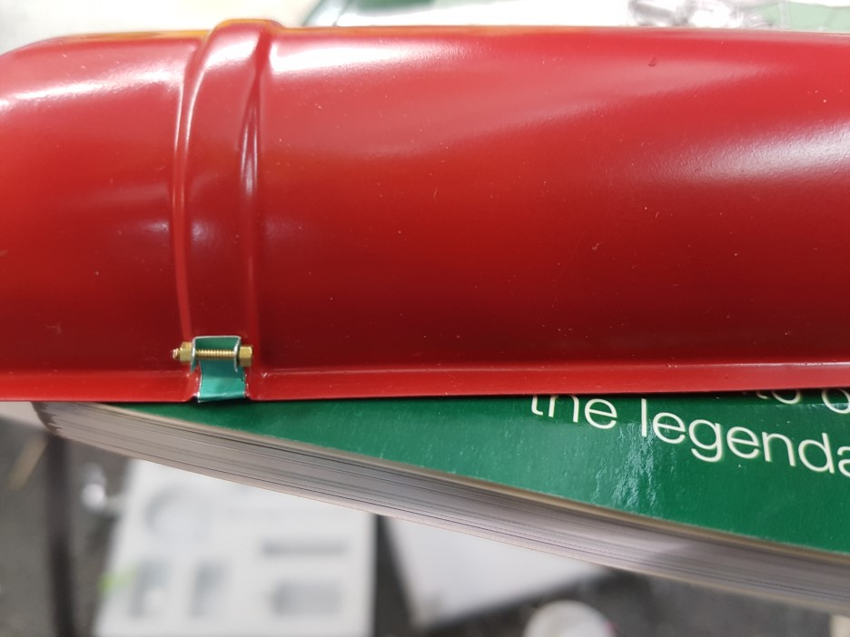

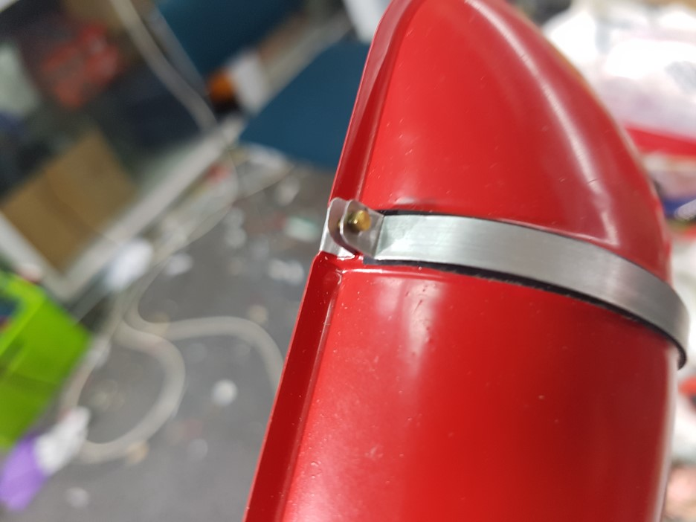

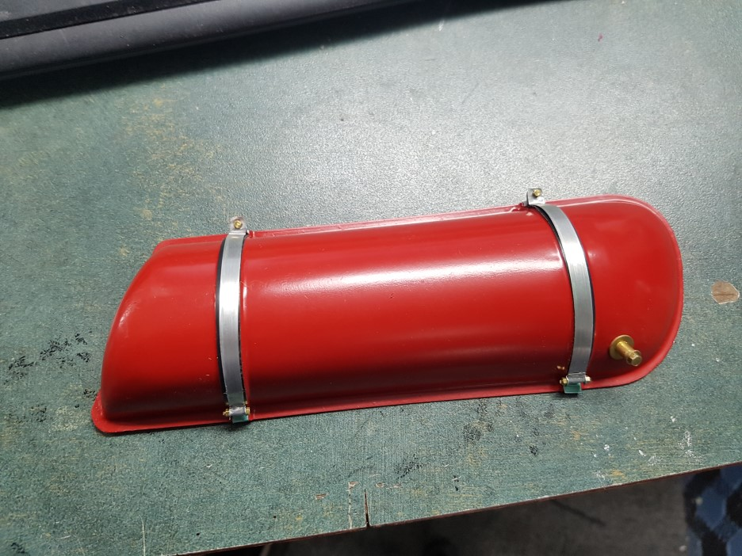

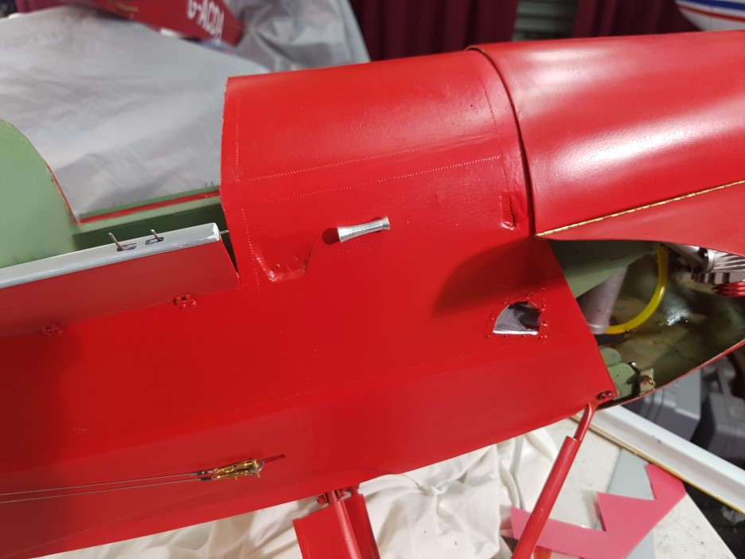

Tiger Moth Windscreen Fabrication..

Just a quick Photo role of how I fabricated my rendition of the Tiger moth windscreens.
Keep points.

- Used 2mm Perspex for the window screens.
- Used litho plate and annealed it so that I could easily work with it.
- Made paper templates to check the fit of the brackets before making them out of aluminum.
- Used small machine screw as per the full size aircraft to make it look more authentic.
- Used white wood glue to glue the Perspex tot eh frames as it is easily cleaned and used 5 min epoxy to glue the mounting brackets.

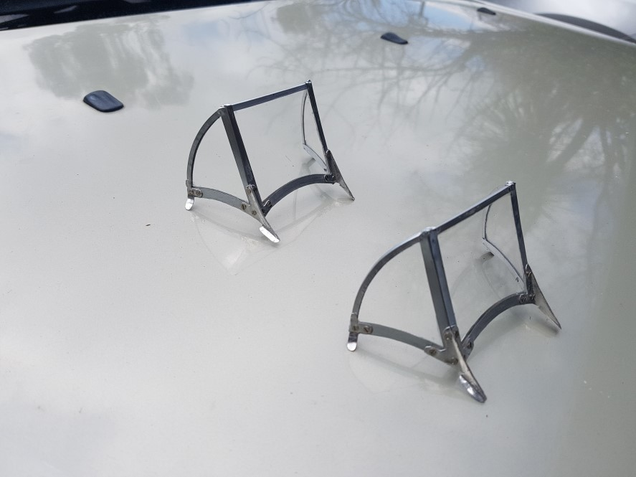

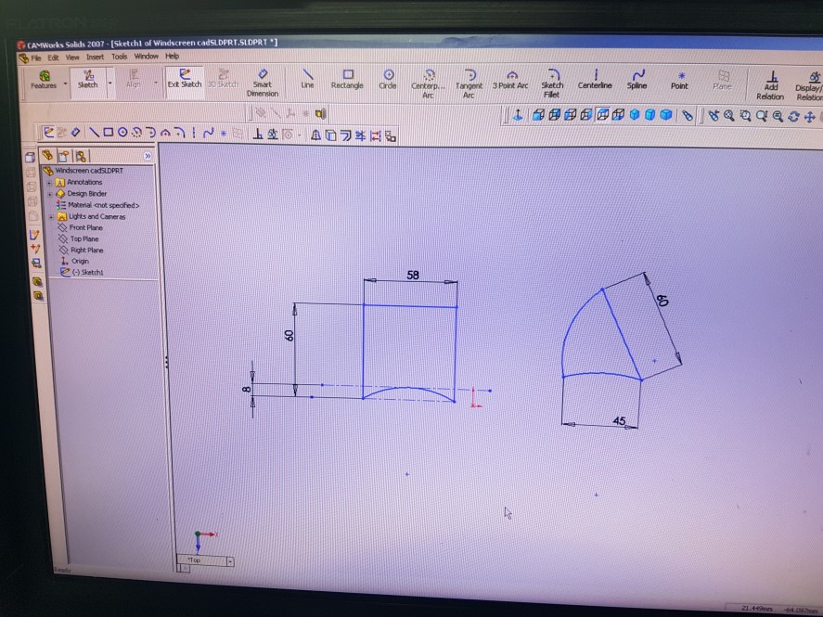

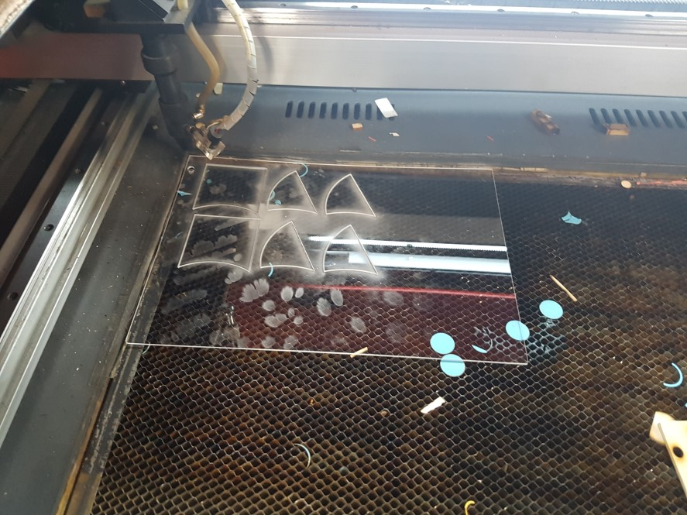

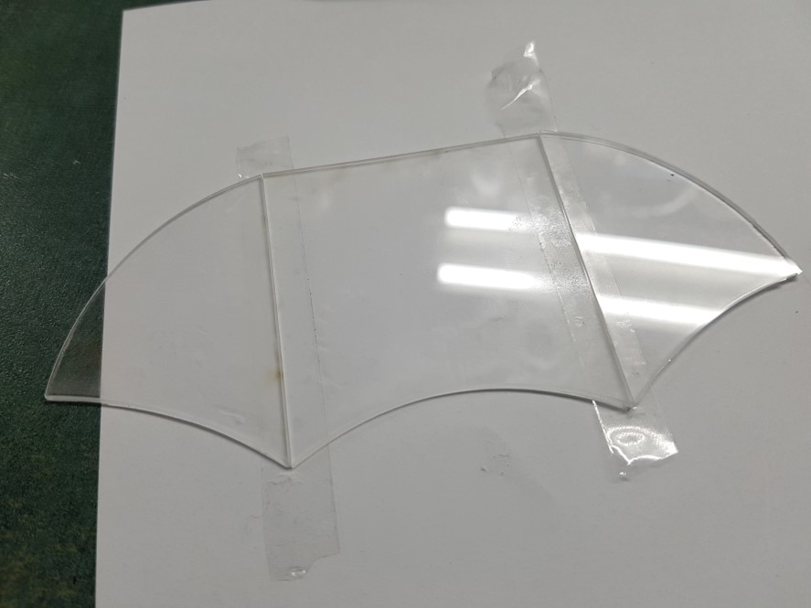

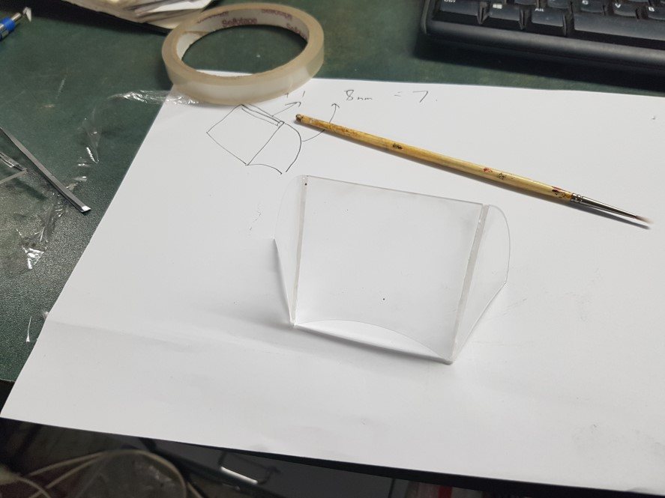

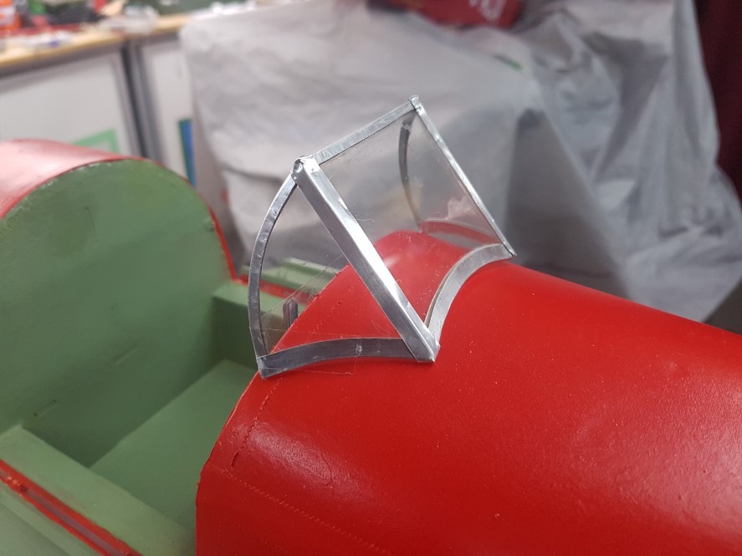

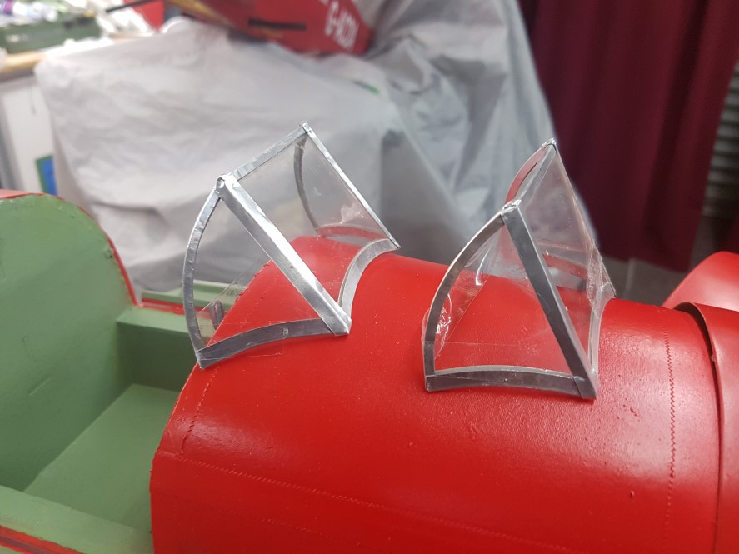

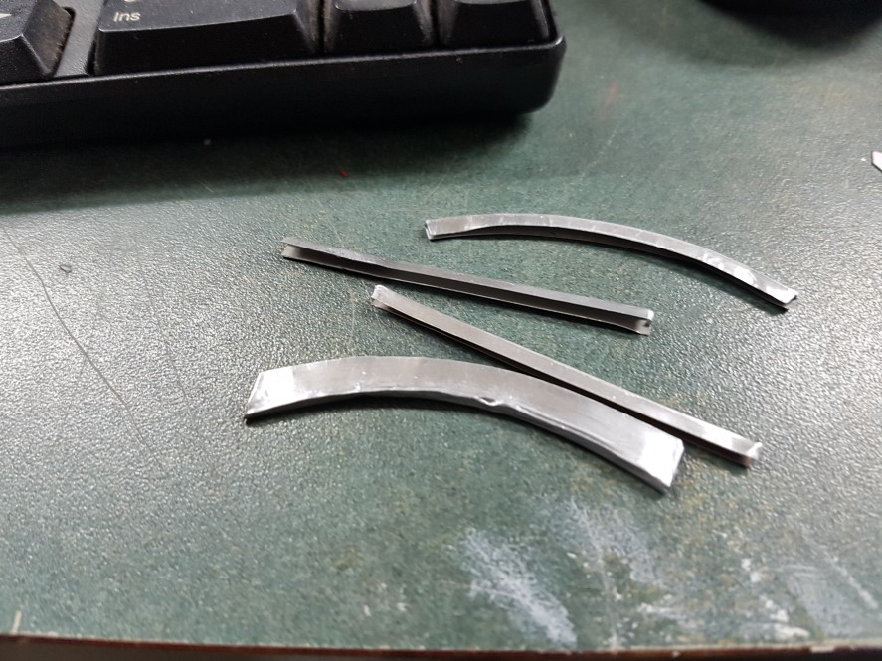

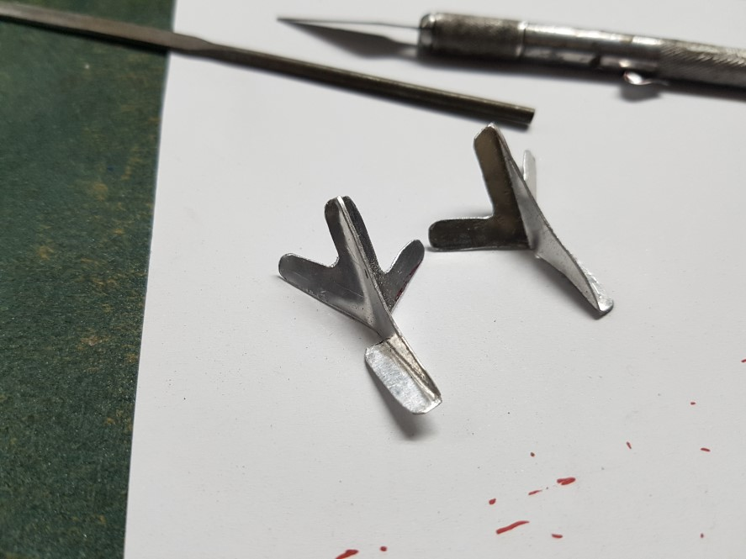

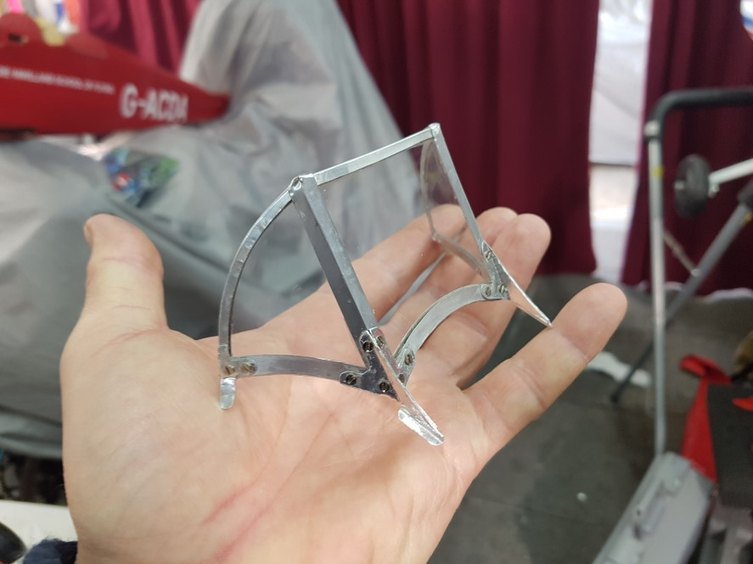

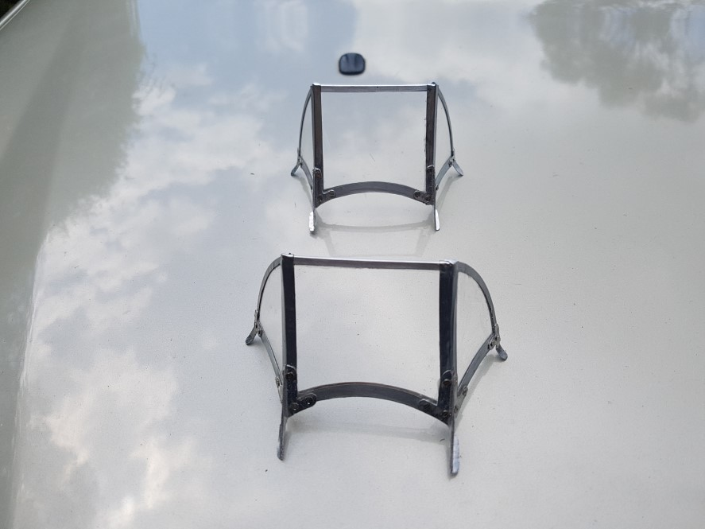

Tiger Moth Cockpit back rests and access hand holds.

Just a quick Photo role of how I fabricated my rendition of the cockpit rear bulkhead and access hand holds.

Keep points:

    - Used aluminum weather flashing so that I could easily work with the aluminum
    - Used a general purpose Dapping / Die forming set for making the access hand holds.
    - Used small machine screw as per the full size aircraft to make the mounting of the access hand holds look more authentic.
    - Cut addition bulk heads and covered them in thin black artificial leather using Kwik grip contact adhesive then added the hand holds and a few pins and it is done for now.

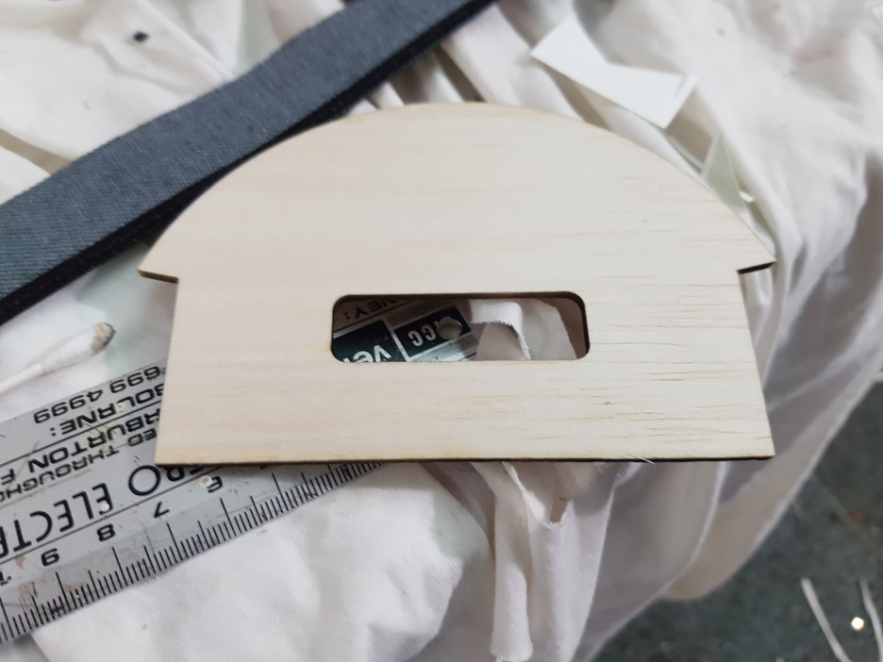

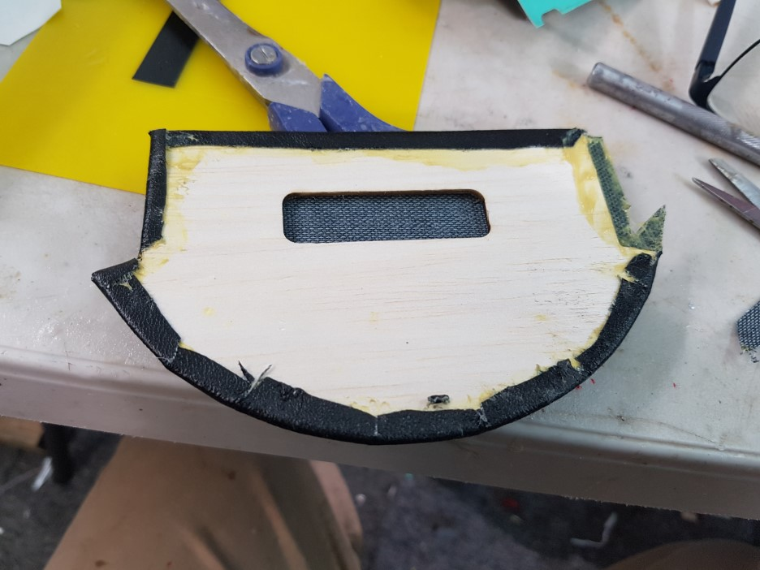

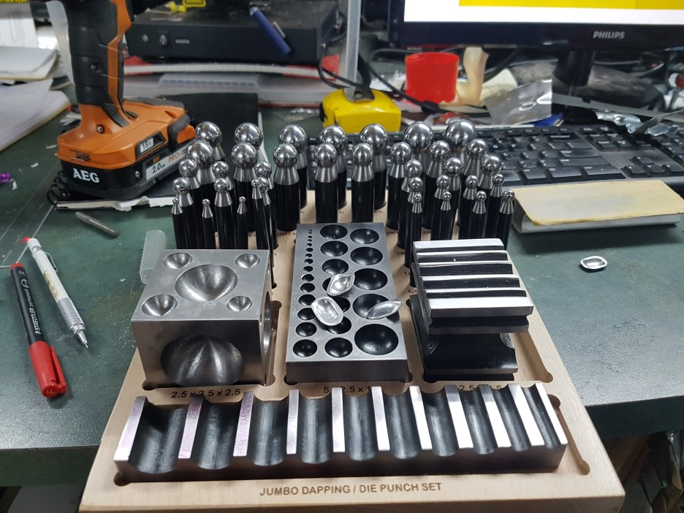

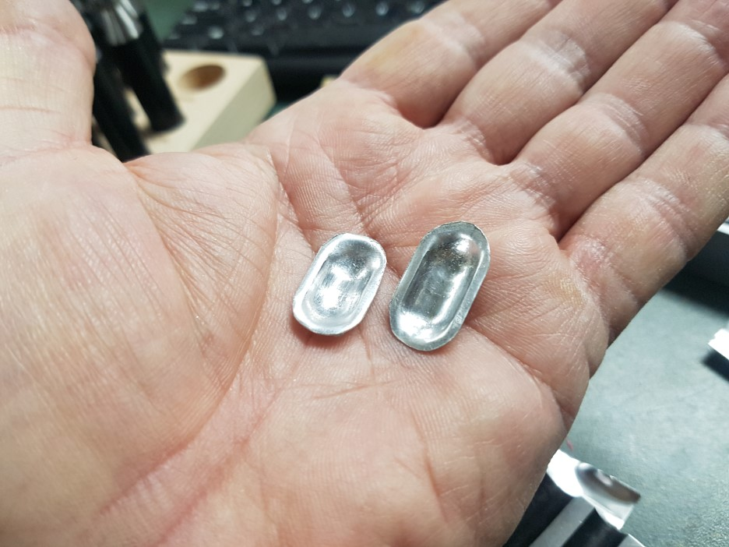

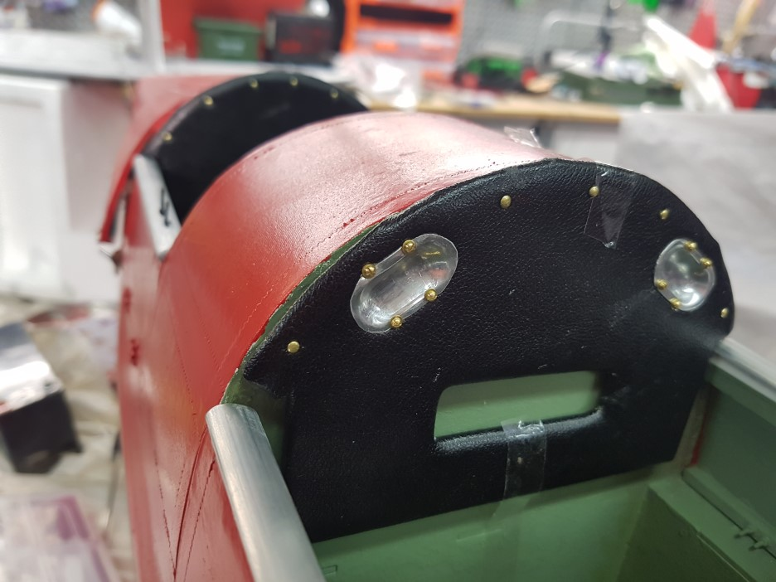

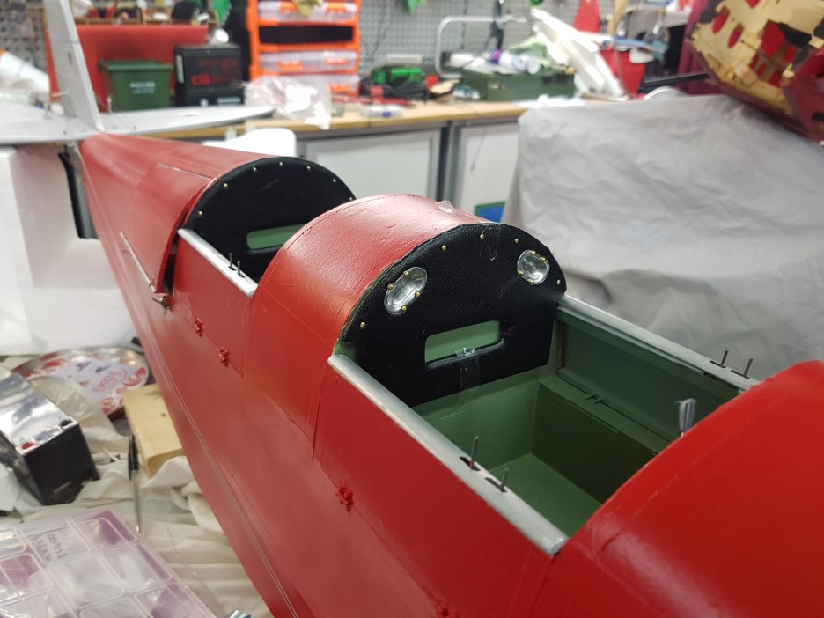

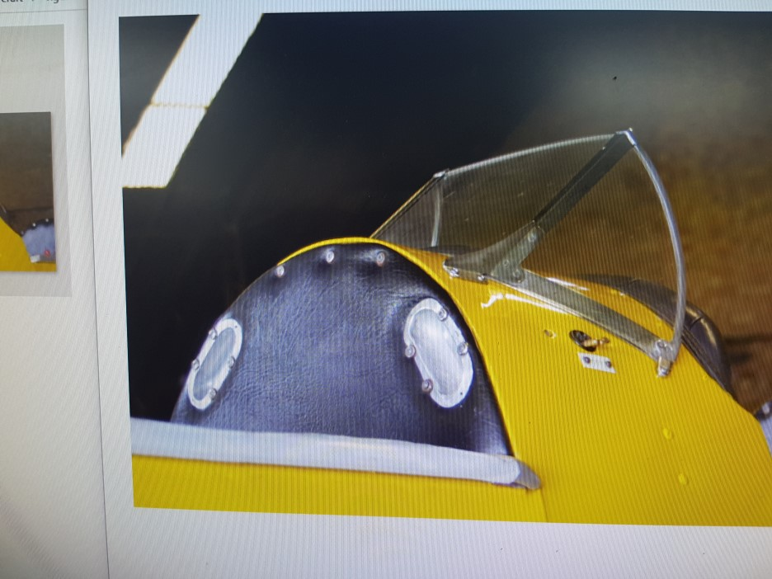

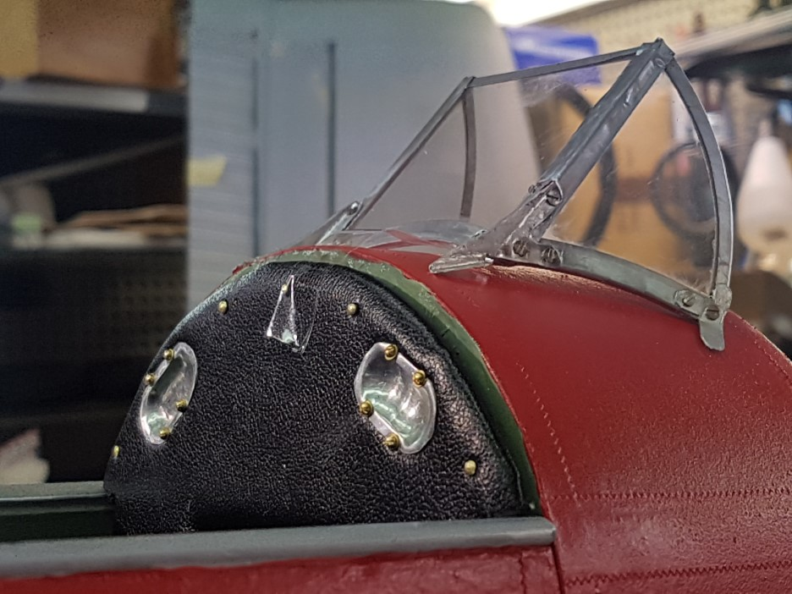

Tiger Moth cockpit doors and cargo hold.

Just a quick Photo role showing the modifications I made to make opening cockpit doors and cargo hold:

    - I used small dolls house brass hinges for the cockpit doors,
    - The hinge for the cargo hold was made using an aluminum tube with a rod through it.
    - I made my own miniature latches for the cockpit doors and also the latches for the cargo hold .A Bit fiddly but work very well.
    - The doors were cut using very fine scalpel saws. There are a range of them available from hobby stores and they work really well for this type of work.
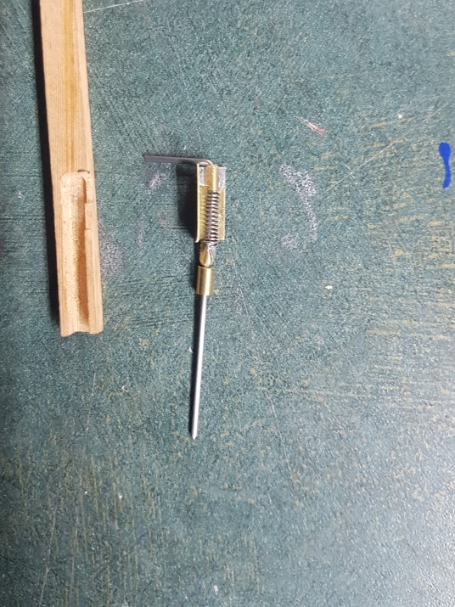

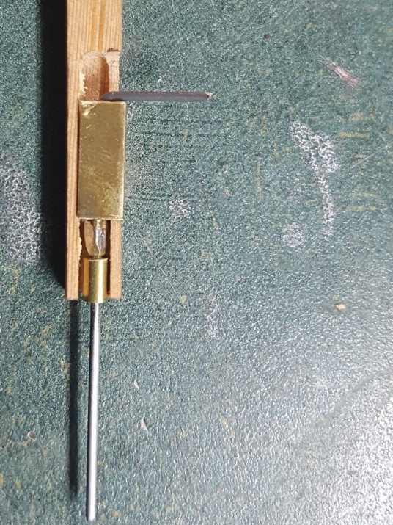

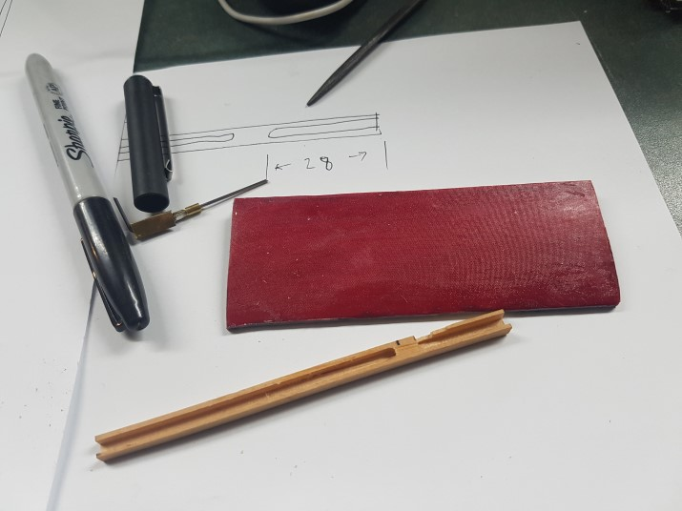
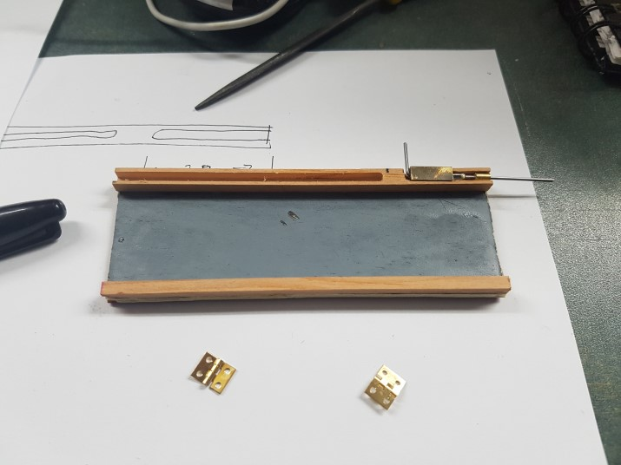

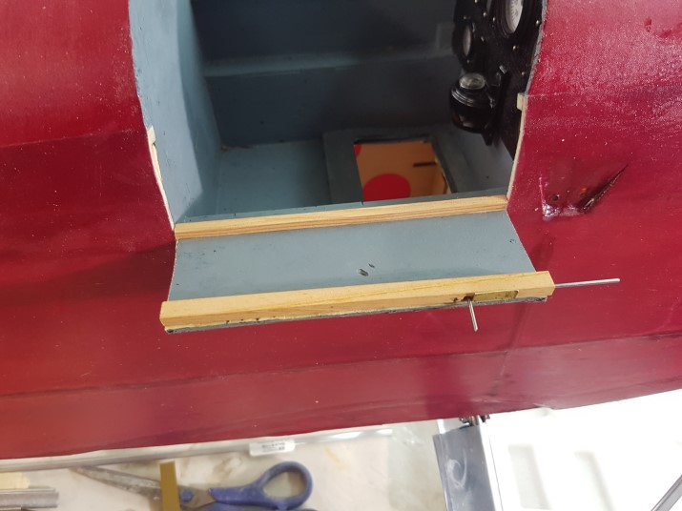

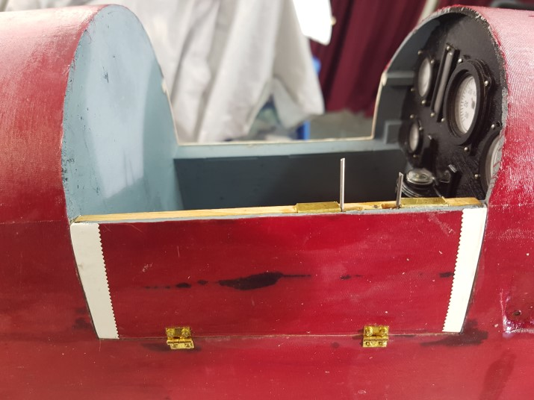

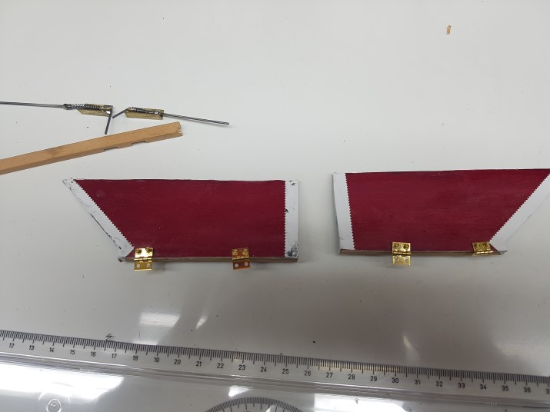

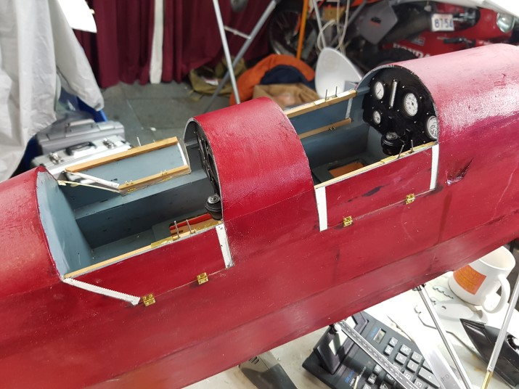

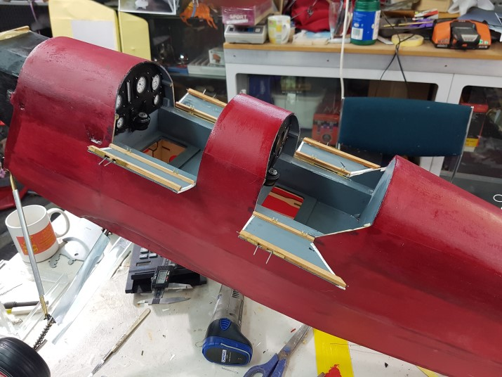

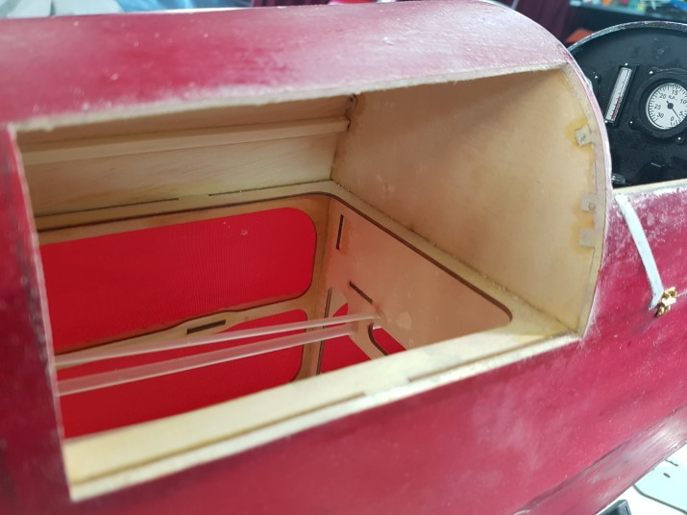

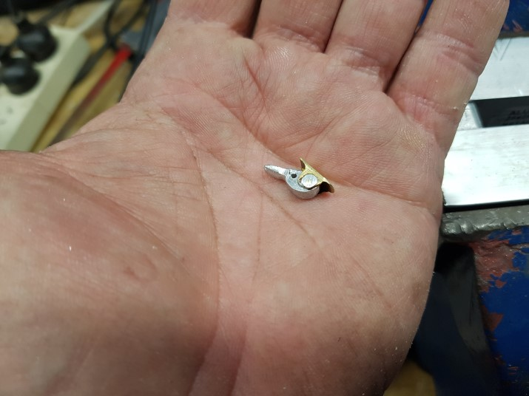

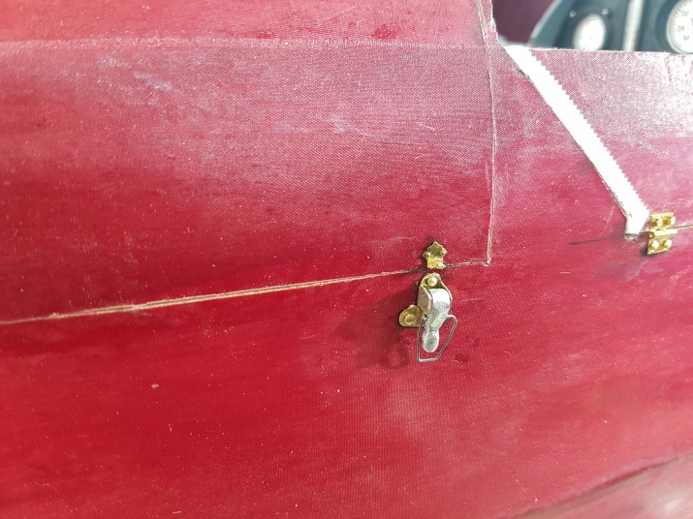

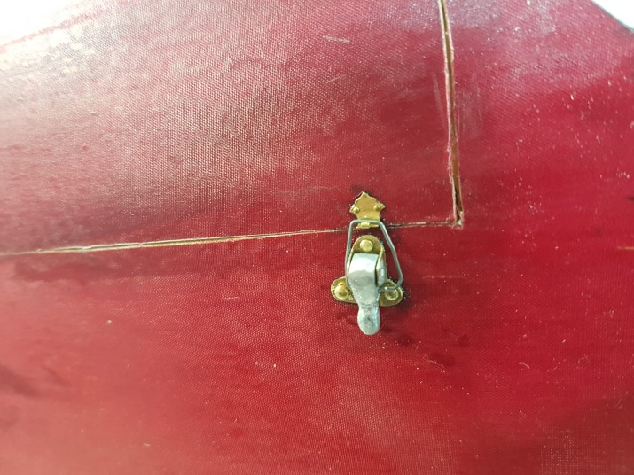

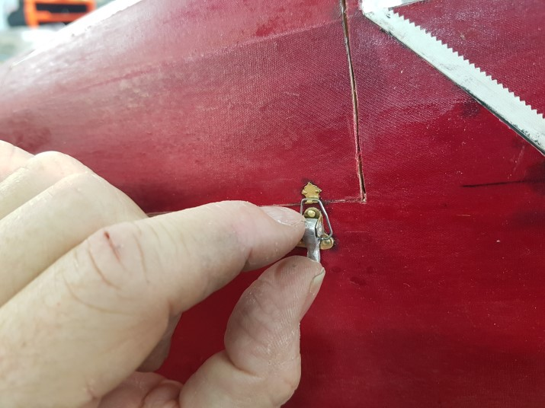

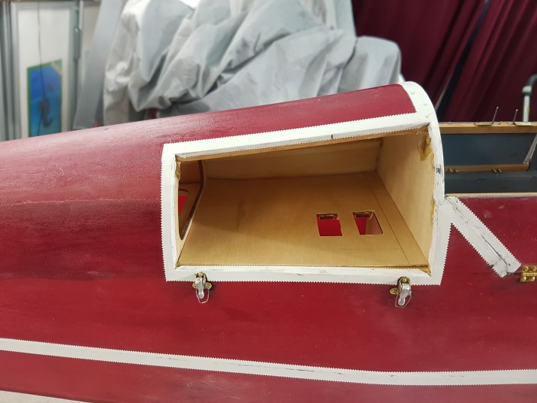

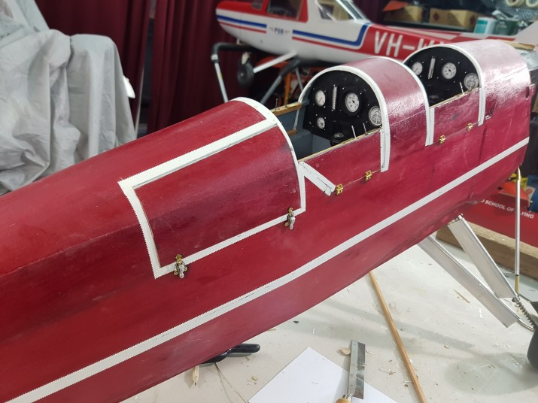

Tiger passenger seat.

Just a quick Photo role of making the Hanger 9 Tiger moth passenger seat and harnesses.

I made paper templates to check the seat parts would fit together and then cut them out of 0.6 mm ply. The ply seat was the lined with annealed litho plate.

I used different colours of 10mm ribbon cut to lengths to make the seat harnesses. The two different colour ribbons were glued together using Selleys shoefix as it is clear and remains flexible.

I used a hand punch and punched the holes in the ribbon and then inserted the correct scale eyelets.

The fittings for the harnesses were made out of little bits of litho plate. I machined up the harness pin on the little Taig lathe.

The clip for the harness pin was made from bent spring steel. Just need to add the retaining string and were are done.

Keep points.
- Seat made from ply and litho plate.
- Harnesses made from ribbon and eyelets.

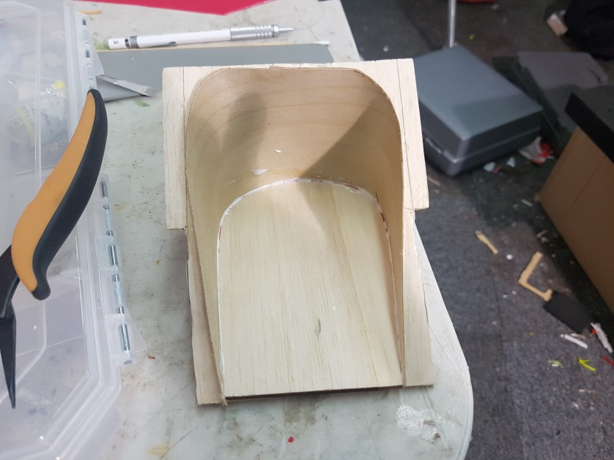

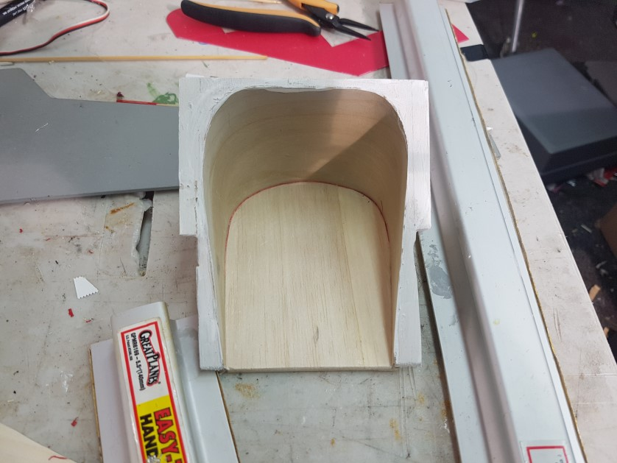

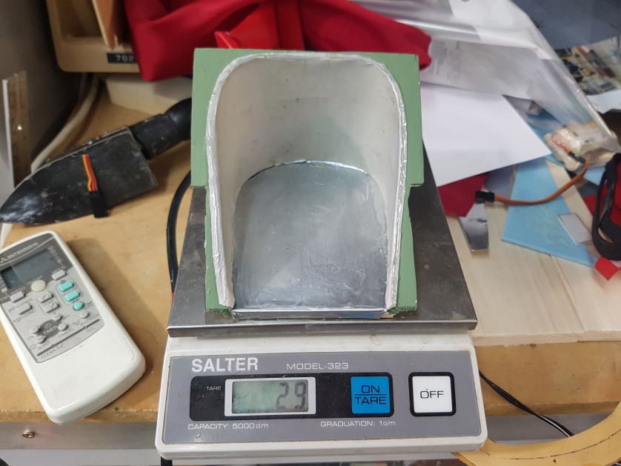

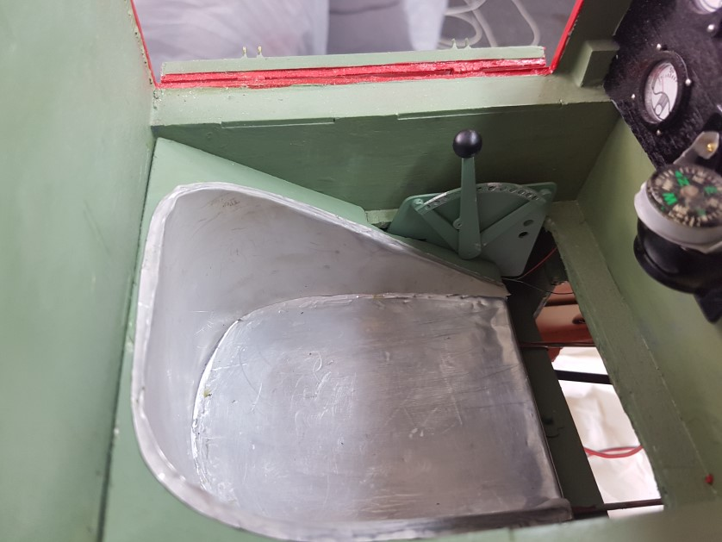

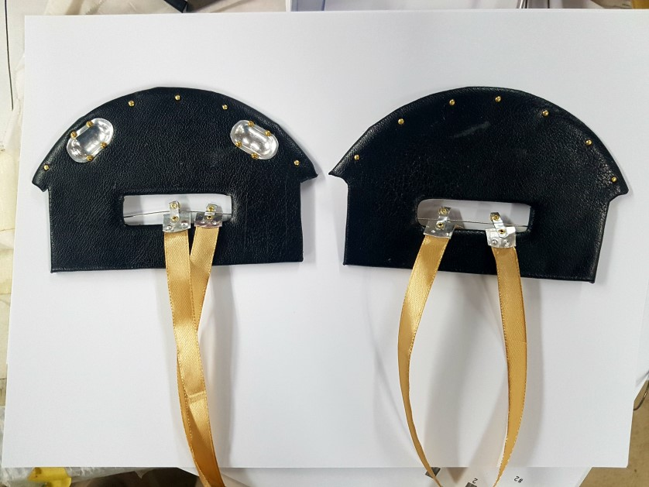

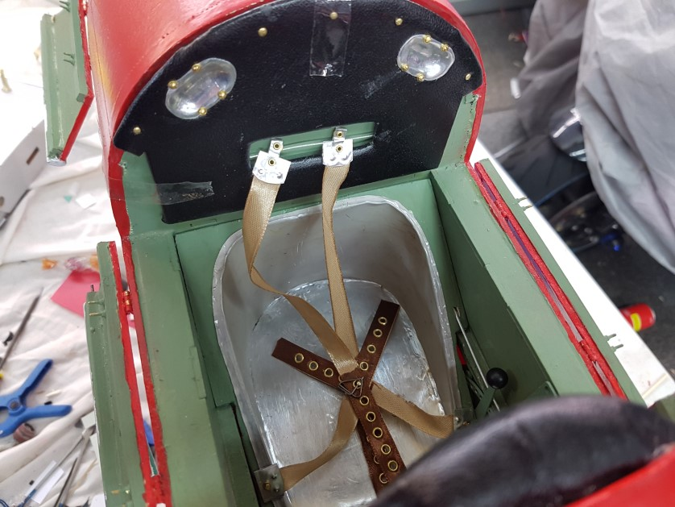

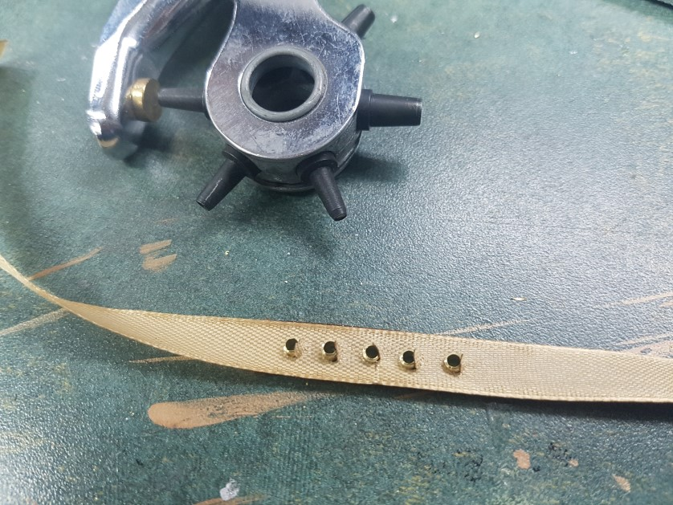

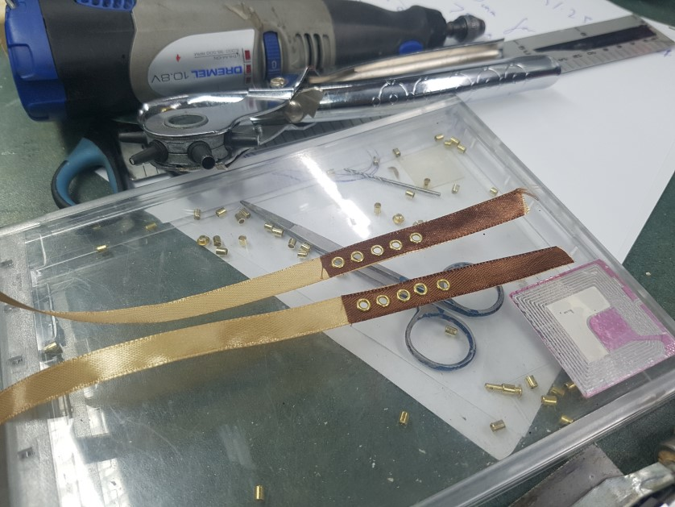

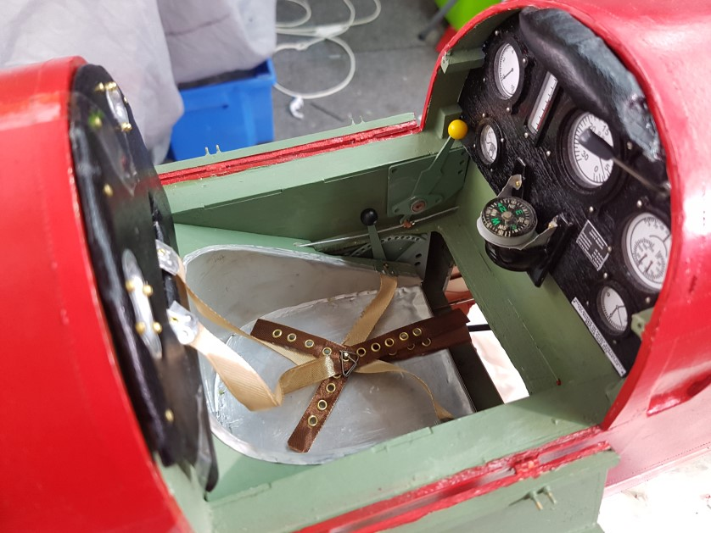

Tiger Moth masking and airbrushing,

Just a quick Photo role airbrushing the signage and registration numbers on the ARF Hangar Tiger project.,

- I use images from the internet to get the font correct. This means loading in the image and tracing it to get the font right using the sticker software.

- I use a Roland sticker cutter that I purchase many years ago, It is a fantastic tool for modelers or even for a club to purchase. You can do the signage around the club and lend it out to members to do here aircraft.

- For making masks I usually use the low take masking contact but I found it would not stick to my silver wings so I used proper sticker vinyl which stayed on sufficiently for me to do the spraying.

- There are many tricks to getting this correct that would be an article all by itself.

- One trick is always to put as little paint down as possible and to spray dry and at an angle to prevent undercut of the mask. Sorry that’s three tricks straight of the bat.

